Unit 7: Atmosphere & Unit 8: Biosphere Test Review

Atmospheric Layers & Composition Questions:
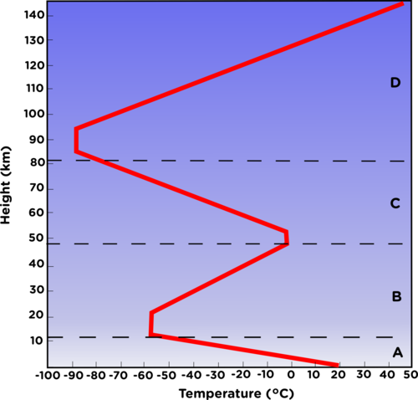
Refer to the graph to the left to determine each layer of the atmosphere: Mesosphere, Exosphere, Thermosphere, Troposphere, and Stratosphere.
A:________________________________
B:________________________________
C:________________________________
D:________________________________
- What are the top three gases in the atmosphere? List each gas and the percentage below.
  - ________________________________________
  - ________________________________________
  - ________________________________________

- Trace gases are about 0.01% of the atmospheric gases, list three examples of trace gases.
  - ________________________________________
  - ________________________________________
  - ________________________________________

- Fill in the chart on layers of the atmosphere.
Layers of the Atmosphere | What is found in this layer?
Troposphere

Stratosphere

Mesosphere

Thermosphere

- The four states of matter are? _________________, ___________________, _________________, ___________
- The atmosphere is composed up ___________________________.
- The air density (increases, decreases) as you move up the atmosphere.
- The air temperature (increases, decreases) as you move up the atmosphere. Moving up the atmosphere is called _____________________________.
Good & Bad Ozone
- Good Ozone in found in the ________________________________ and bad ozone is found in the ________________________.
- Good Ozone protects humans from ________________________________________.
- Good Ozone is destroyed by ______________________ that come from ________________________________.
- Bad Ozone is created from _________________________, _______________________________, and ______________________________.
Air Pollution
- Largest source of human caused air pollution?

- Fill out the chart on air pollution:
Types of Air Pollution | Causes – Where does it come from? | Effects – Why is it bad?
Particulate Matter
Nitrogen Oxides
Carbon Monoxide
Sulfur Oxides
Lead

Weather & Fronts
- Clouds are made up of ______________________ droplets. In order for these droplets to form clouds they require _______________________________________.

- Storm clouds are called ______________________________________.

- Fill out the chart on fronts:
Type of Front | Weather Caused by the front | Front Symbol
Cold Front
Warm Front
Occluded Front
Stationary Front

- Air masses have the same moisture and temperature. Match the air mass terms to the correct statement.
- Maritime (m) _______________ | - Cold temperature
- Continental (c) _______________ | - Warm temperature
- Tropical _______________ | - Moist air
- Polar _______________ | - Dry air

- Wind and weather are caused by the ________________________________________________.
- What is the difference between climate and weather?

Climate Change
- Climate change is caused by nature and human actions. What are some examples of natural events that cause climate change? What are some examples of human actions that cause climate change?

- What are some negative effects of climate change?

Reading a Weather Map
- What is the temperature? _____________________
- What is the pressure?
______________________
- What is the wind direction?
______________________
- What is cloud cover?
______________________
- What is the wind speed?
______________________
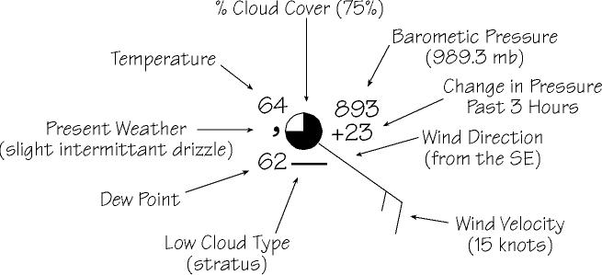

Biomes & Diversity Questions:
- What is the most diverse biome on earth?

- What is an invasive species? Why are they harmful?

- Abiotic means non-living and biotic means living. What are some biotic and abiotic factors found in an ecosystem?
Examples:
Biotic
Abiotic

- Know the biomes covered in class. You are welcome to put some of that information below.

