Name:______________________________________________________________Period:_____________Date:________________________

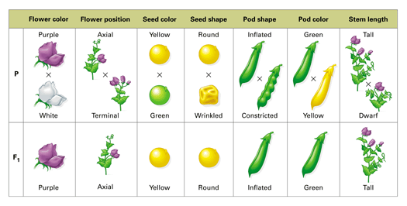

|  |  |  |
| --- | --- | --- |
| **Term** | **Definition** | **Example** |
|  | A segment of DNA that codes for a protein |  |
|  | Alternate forms of a gene |  |
|  | Two alleles are the same. |  |
|  | Two alleles are different. |  |
|  | Trait that is automatically seen even when paired with a recessive allele. |  |
|  | Trait that is only seen when two recessive alleles are present. |  |
|  | Genetic make-up of an individual. |  |
|  | Physical characteristic. How you see the trait. |  |
|  | A box that is used to predict the probability of offspring when crossing two parents. |  |

**What is genetics?**

Genetics is the branch of biology that studies *__________________* or the passing of traits from parent to offspring.

_________________ ___________________ **(1822-1884)** today he is considered to be the ***father of modern genetics***. Worked with _________________________.

Mendel’s findings led to two laws of heredity:

* _____________________________________ - 2 alleles for a trait **separate** during meiosis **(chromosomes separate)**
* _________________________________________________ - alleles for different traits separate **independently** from one another during meiosis. In other words inheritance of one trait does not influence inheritance of another. For example if you have blond hair you will not necessarily get blue eyes. These traits are inherited separately.

# Nature vs. Nurture:

# Genes determine the physical trait, but ____________________ can also play a role in how the trait is expressed.

**Example 1:** Height and weight. Genes determine this trait, but environment can play a big role. If a person has genes for being very tall, but does not have the proper nutrition while growing up, then they may not be as tall as their genes would allow.

**Example 2:** Fur color in some animals. Genes determine fur color, but some animals have fur that changes depending on the season. The arctic fox for instance has a white coat in the winter but a brown coat in the summer.

* What are the 3 main steps of the cell cycle?
* What is the longest phase of the cell cycle?
* What 2 main things happen during this phase?
* After DNA copies what does it look like?
* What steps involve the nucleus dividing?
* What step involves the cytoplasm dividing?

|  |  |
| --- | --- |
|  |  |
|  |  |

|  |  |
| --- | --- |
|  |  |
|  |  |

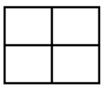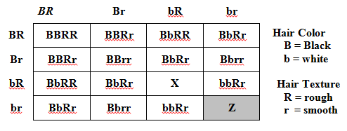

What letters would go in Box X? ___________________

What letters would go in Box Y? ___________________

What are the genotypes of the parent’s of this cross? ___________ X _____________

What percent of offspring are expected to have a white coat of fur? ______________

__________________________ – looks at two traits at a time. Shows that traits are inherited independently of one another (Law of Independent Assortment)

**If any of the puppies are deaf, the male’s genotype MUST BE _______; but assuming a litter of at least about 4 to 5 puppies or more, if they can all hear, his genotype is MOST LIKELY __________.**

**Test Cross -** Used to determine the unknown genotype of an organism. For example of a plant is tall you don’t know if it is TT or Tt. So you do a test cross to figure it out. You must cross the dominant organism with a _________________.

**Sample test cross**: In dogs, there is a hereditary deafness caused by a recessive gene, “d.” A kennel owner has a male dog that she wants to use for breeding purposes if possible. The dog can **hear**, so the owner knows his genotype is either **DD** or **Dd**. If the dog’s genotype is Dd, the owner does not wish to spend the money to use him for breeding.

**Assume the male is DD Assume the male is Dd**

**Probability & Punnett Squares**

_____________________ - the likelihood that an event will occur.

_____________________ _____________________ are used to determine the probability that specific traits will be passed down from parent to offspring.

_____________________ cross- a cross that involves one pair of contrasting traits.

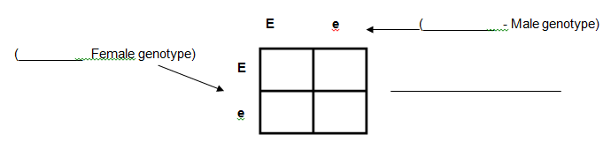

**Practice Problem: In pea plants, tall is dominant over short. (T = tall, t = short)**

1. Cross a heterozygous tall plant with a short plant.
2. Genotypes of heterozygous tall ___________ X short plant __________. These are the parents.
3. Fill in the Punnett square to see the probability of getting each type of offspring:

4a. What percent of the offspring are tall? ______, short? ______

b. Genotypic ratio: ________TT : ________Tt : _________tt

c. Phenotypic ration: ________tall : ______ short

|  |  |  |  |  |
| --- | --- | --- | --- | --- |
| **Term** | **Definition** | **RR** | **Rr** | **rr** |
| **Complete Dominance** | One allele is dominant over the other.  Only 2 possible phenotypes |  |  |  |
| **Incomplete Dominance** | The dominant allele will not fully cover up a recessive allele and the trait will be a result of the two **blending** or **mixing** together.  3 possible phenotypes |  |  |  |
| **Codominance** | Two different alleles are expressed at the **SAME** time.  3 possible phenotypes |  |  |  |

In carnations, **incomplete dominance** can be seen in flower color: Red (RR), Pink (Rr), White (rr)

**Cross two pink carnations. Genotypes of the parents ______ X ______**

|  |  |
| --- | --- |
|  |  |
|  |  |

# Genotypic ratio: ______RR:_____Rr:______rr

# Phenotypic ratio: ______red:_____pink:______white

# What percent of the offspring are pink? _______

The allele for red hair (HR) is **codominant** with the allele for white hair (HW) in cattle. Cattle that have the genotypes HRHW are called roan because their hair is a mixture of red and white hairs.

Red (HR HR) Roan(HRHW) White (HW HW)

**Cross a red cow and a white bull. What are the genotypes of the parents? ________ X _______**

|  |  |
| --- | --- |
|  |  |
|  |  |

# Genotypic ratio: ______ HRHR:_____ HRHW:______ HWHW

# Phenotypic ratio: ______red:_____roan:______white

# What percent of the offspring are roan? _______

**Cell Cycle Questions**

* What is the longest phase of the cell cycle? __________________________________
* What 2 main things happen during this phase?_________________________
* What steps involve the nucleus dividing?___________________________
* What step involves the cytoplasm dividing? __________________________________

Sickle cell anemia is another example of **incomplete dominance**. Carriers of the allele have a much milder form of the disease.

Normal - (HAHA), Carrier - (HAHS), Sickle cell - (HSHS)

Complete a punnett square to determine the chances of two sickle cell carriers having a homozygous normal child?

|  |  |
| --- | --- |
|  |  |
|  |  |

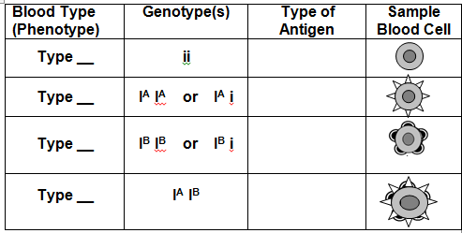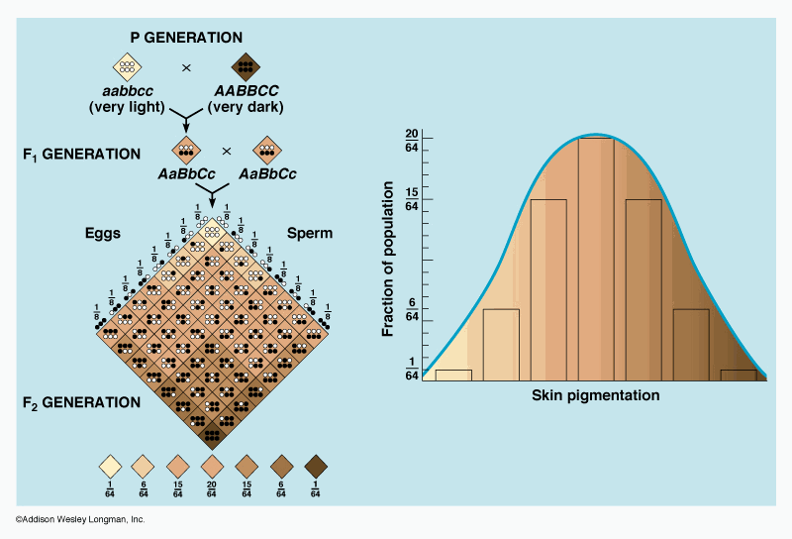

**Sex-Linked Traits**

Genes which are located on the sex chromosomes are said to be **sex-___**___________ or ______-linked.

Sex-linked traits occur more frequently in _________because they have only ______ **X chromosome**.

Sex-linked traits include: color blindness, hemophilia and muscular dystrophy.

XNXN = Normal Female XNY = Normal Male

XNXn = Normal Female Carrier XnY = Male with disorder

XnXn = Female with disorder

**Blood Type Practice Problems:**

1. A man with type O blood marries a woman with type AB blood, what are the possible blood types of their children?

|  |  |
| --- | --- |
|  |  |
|  |  |

What is the probability of having a child with each of the following blood types. - Type A? ____________ - Type B? _________

- Type AB? ______ - Type O? ________

1. Is it possible for a man with type A blood and a woman with type B blood to have one child with type O blood and another child with type AB Blood? Why or why not? Show your work!!!

|  |  |
| --- | --- |
|  |  |
|  |  |

**Multiple Alleles** - A gene that has **more than ________** alleles (or forms of a gene). In other words, not just one dominant and one recessive allele (i.e. R and r). Use the same common letter with superscripts to show **only one gene** is playing a role.

**Polygenic Traits** are controlled by ______________ ________________ . See lots of variety

Ex: ___________________________________________________________

1. Using a Punnett square, cross a carrier female with a hemophilia male.

What are the genotypes of the parents? _______ X _______

|  |  |
| --- | --- |
|  |  |
|  |  |

1. What percentage of this couple’s **daughters** will have hemophilia? _________
2. What percentage of this couple’s **sons** will have hemophilia? __________
3. What percent of this couple’s children will have hemophilia? ___________

**Sex-Linked Practice Problems:**

1. **Cross a carrier female for colorblindness with a male that is normal for colorblindness.**

What are the genotypes of the parents? _______ X _______

|  |  |
| --- | --- |
|  |  |
|  |  |

What is the probability that one of their children will be colorblind? _____

What is the probability of a son being colorblind? ____________

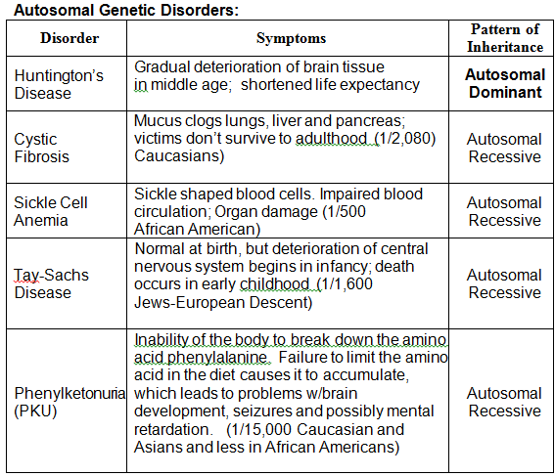

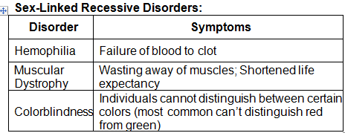

Tips to determining pattern of inheritance in a pedigree:

* Autosomal - about ___________ males and females shaded
* Sex-linked – more ____________ are shaded in.
* Dominant – for every child with the disease at least one parent is shaded
* Recessive – if one set of parents are ________________ parents but kid has the disease.

**Pedigrees** – family trees that follow a trait/disorder

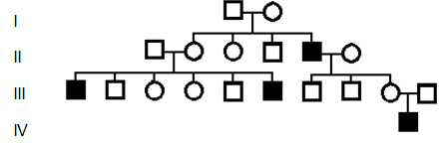

Symbols – square = ________________, circle = ____________

Shaded individual – person has the disorder/trait.

Roman numerals - __________________

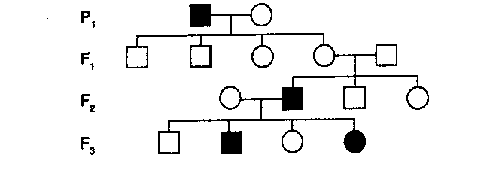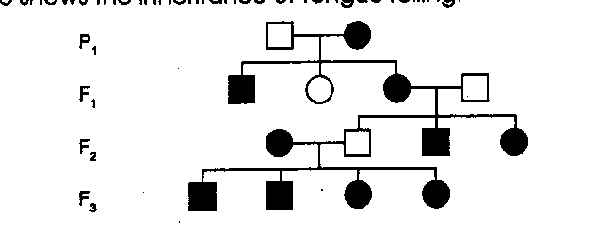

Circle one in each pair:

Autosomal or Sex-linked

Dominant or Recessive



Circle one in each pair:

Autosomal or Sex-linked

Dominant or Recessive

Circle one in each pair:

Autosomal or Sex-linked

Dominant or Recessive

# PRACTICE of Vocab from Page 1.

|  |  |  |
| --- | --- | --- |
| TRAIT | DOMINANT ALLELE | **RECESSIVE ALLELE** |
| Seed shape | R = round | r = wrinkled |
| Seed color | Y = yellow | y = green |
| Seed coat color | G = gray | g = white |
| Flower position | A = axial | a = terminal |
| Plant height | T = tall | t = short |

**Complete the following table using the symbols and traits found above:**

|  |  |  |
| --- | --- | --- |
| Trait | Genotype (symbol) | Phenotype |
| seed shape | RR |  |
| seed shape | Rr |  |
| seed shape | rr |  |
| plant height |  | tall |
| plant height |  | short |
| flower position |  | terminal |
| flower position |  | axial |
| seed coat color | Gg |  |

**Write the correct symbols for the following genotypes. Circle those that are not possible.**

pure tall stems _______ homozygous yellow seeds _______ pure short stems _______

pure green seeds _______ homozygous terminal flowers _______ hybrid round seeds _______

pure round seeds _______ homozygous axial flowers _______ homozygous wrinkled seeds_____

hybrid tall stems _______ Heterozygous wrinkled seeds _______ hybrid axial flowers _______

heterozygous short stems_____ heterozygous yellow seeds _______ heterozygous seed coat color _______

1. Why are some of these not possible? ____________________________________________
2. Can I always identify the genotype if I know the phenotype? ________________ Explain your answer. ____________________________________________________________________

**Punnett Square Practice**

1. **Red flowers are dominant to white flowers. (R = red, r = white)**
2. **Cross** a homozygous red plant with a white plant:

|  |  |
| --- | --- |
|  |  |
|  |  |

**Parent genotypes ____________ x ____________**

1. What is the **genotypic** **ratio**? ___RR : ___Rr : ___rr
2. What is the **phenotypic** **ratio**? ___red : ___white
3. **In pea plants, round seeds are dominant to wrinkled seeds. (R=round, r=wrinkled)**
4. Cross a heterozygous plant with another heterozygous plant.
5. What are the **genotypes** of both parents? **Parent (P)**: ____________ **X** ___________

|  |  |
| --- | --- |
|  |  |
|  |  |

1. What is the **genotypic** **ratio**? ___RR : ___Rr : ___rr
2. What is the **phenotypic** **ratio**? _____round : ___wrinkled
3. **In pea plants, green pea pods are dominant to yellow pea pods. (G=green, g=yellow)**
4. Cross a heterozygous plant with a yellow plant.
5. What are the genotypes of both parents? **Parent (P)**: ___________ **X** ___________

|  |  |
| --- | --- |
|  |  |
|  |  |

1. What is the **genotypic** **ratio**? ___GG: ___Gg: ___gg
2. What is the **phenotypic** **ratio**? _____green : ___yellow

|  |  |
| --- | --- |
|  |  |
|  |  |

|  |  |
| --- | --- |
|  |  |
|  |  |

1. When a tall plant is crossed with a short plant, some of the offspring are short. What are the genotypes of the parents and the offspring? You should have two punnett squares drawn to prove your point since there are two ways a plant can be tall. Cross out the one that does not give you any short plants. This can’t be the parent.

1. Three-fourths (3/4) of the plants produced by a cross between two unknown pea plants have axial flowers and ¼ have terminal flowers. What are the genotypes of the parent plants? SHOW YOUR WORK!

|  |  |
| --- | --- |
|  |  |
|  |  |