Name:______________________________________________________________Period:_____________Date:________________________

* **___________________________ - breaking bonds between atoms and forming new ones to make new compounds**
* **Reactant - _____________________________________ Product - ______________________________________________________**

**In the equation, label the reactants and products:** C6H12O6 + 6O2  6CO2 + 6H2O + ATP

_________________ _______________________

|  |  |  |
| --- | --- | --- |
|  | **Photosynthesis** | **Cellular Respiration** |
| **Definition** |  | **Analogy: glucose is like a _____________, ATP is like   _______________** |
| **Equation** |  |  |
| **Location** | _________________________  Notice the stacks inside of the chloroplast. These stacks absorb sunlight. This arrangement increases the amount of _____________________________________ to absorb as much sunlight as possible. | http://penrules.com/_Media/art_mito_300.png _______________________________ Notice the highly folded inner membrane. These folds increase the amount of __________________________ so lots of ATP can be made. |

Plants contain _________________________ that _______________ some wavelengths of light and ________________ others. For example, if a plant appears red, the plant ________________ this color. ______________________ is one of the most abundant pigments in a plant which absorbs the red and blue colors of the spectrum and reflects ________________ which is what makes plants appear green. The light plants absorb is used to undergo __________________________.

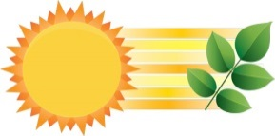

**2 Types of Cellular Respiration**

|  |  |  |
| --- | --- | --- |
|  | **Aerobic Respiration** | **Anaerobic Respiration (______________________)** |
| **Definition** | Occurs with _____________________________ | Occurs without _____________________________ |
| **Equations** | **___________ + _________ 🡪 _______ + _______ + ____ATP**  Which reaction (aerobic or anaerobic) results in more energy, which would allow for more work to be done?  ____________________________ | **2 Types:**  **Alcoholic Fermentation** (occurs in __________________)–  ____________ 🡪____________ + ________ + ____ ATP  This process is used in baking bread and in brewing.  What causes bread dough to rise? _____________  **Lactic Acid Fermentation** (occurs in ____________________ cells)  ____________ 🡪____________ + ________ + ____ ATP  This process occurs when exercising. If your muscles are depleted of oxygen they will switch to lactic acid fermenation. Lactic acid builds up in the muscles and creates that ___________________ feeling.  What reactant is missing from both of the equations above? ___________ |

**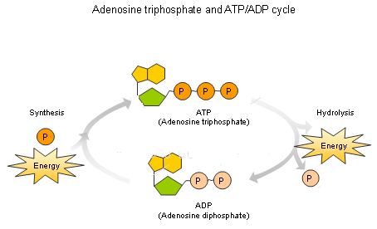  
ATP/ADP Cycle**

Energy is stored in the bond between the ______________________________, when the bonds break energy is __________________________ to power chemical reactions, your cells and ultimately your body

The goal of cellular respiration is to take ADP and create ATP by adding on a _______________.