**Unit 1**

**Name:_______________________________________________Period:__________Date:________________________**

**What is biology????**

**Bio=_________ ology=_____________**

**So biology is ____________________**

**I have a theory the NE Patriots will win the Super Bowl this year. Is this really a theory????? If not what is a theory?**

* _______________________________ - An educated guess about what you think will happen.
* _______________________________ - A very well supported explanation of something that has been observed. It tries to explain why something is happening. It can never really be proven, just highly supported by data.
* __________________________ - A description of something that has been observed. It is known to be true.
* __________________________ - A statement based on what you see. Does not try to explain.
* __________________________ - A logical interpretation of what you see based on prior knowledge.

**BIOLOGY**

**Characteristics of Life (all living things have ALL of these characteristics)**

* ________________________________________
* ________________________________________
* ________________________________________
* ________________________________________
* ________________________________________
* ________________________________________
* ________________________________________
* ________________________________________
* ________________________________________



**Steps of the Scientific Method**

* ______________________________________________________________
* ______________________________________________________________
* ______________________________________________________________
* ______________________________________________________________
* ______________________________________________________________
* ______________________________________________________________
* ______________________________________________________________

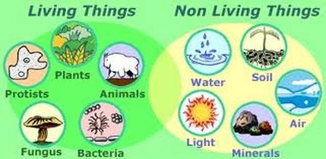

C:\Users\smorey\AppData\Local\Microsoft\Windows\Temporary Internet Files\Content.IE5\S0E3IBG3\MC900391454[1].wmf

**Let’s Practice:**

**Design a lab to test the effect of different types of fertilizers on plant growth.**

* ___________________ - _____________________
* ___________________ - _____________________
* ___________________ - _____________________
* ___________________ - _____________________
* ___________________ - ____________________________   
    
  __________________________________________________  
    
  __________________________________________________

**How do I design a lab?**

**An experiment includes these things:**

* _______________________________ - the **ONE** thing you change in the setup
* _______________________________ - Data or what you measure  
  + ____________________________________ - numbers
  + ____________________________________ - words or descriptions
* __________________________ - Group that does not receive treatment. What   
   you compare your results back to.
* __________________________ - Group(s) that receive the treatment (test   
   groups).
* __________________________ - Things that are kept the same between all   
   the setups (also called   
   ________________________________

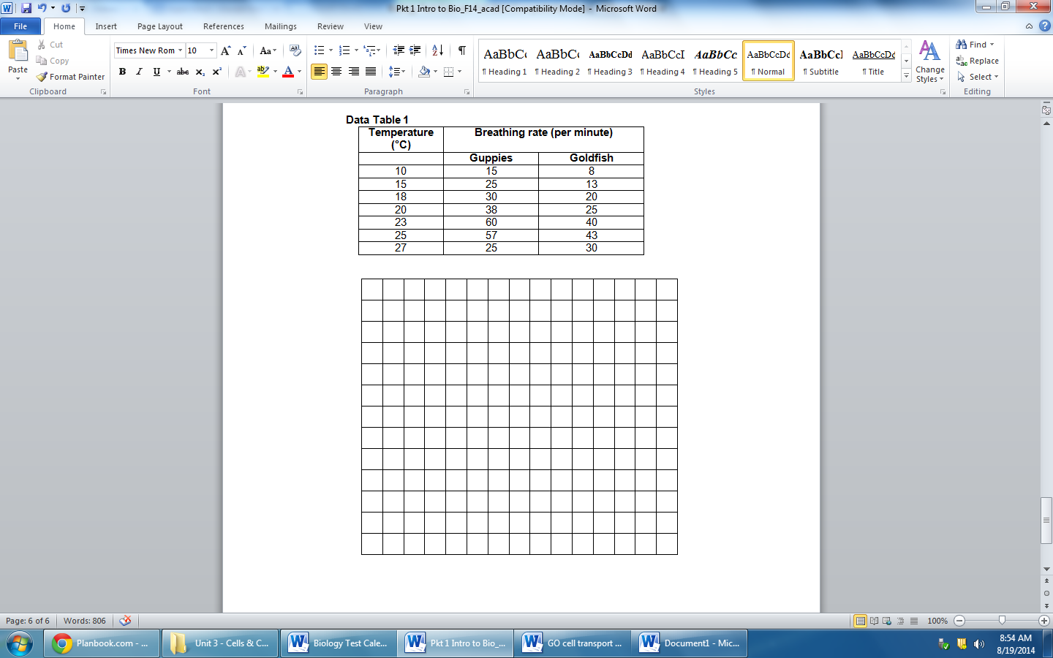

**Now that I have all of this data, how do I organize it?**

**A graph includes these things:**

* **Independent** **variable** –placed on the **_______** axis(horizontal axis).
* **Dependent variable** – always placed on the **__________ axis** (vertical axis).
* **_____________________________** – compares data need when more than one line or sets of bars
* **__________________________** – tells what the graph is about
* **_____________________________** – the scale on both the x and y-axis usually begin with zero (some exceptions include time/dates).
* Values must increase by ___________________ spacing and the same numeric intervals. (Jump by 1’s, 10’s, 100’s, etc.)
* Do the X and Y axes have to have the same scale (i.e. jump by the same interval)? ________