**Composition and Structure of the Atmosphere**

Date:

SWBAT: Describe the composition of the atmosphere. Diagram/describe the layers of the earth’s atmosphere.

|  |  |  |  |  |
| --- | --- | --- | --- | --- |
| Term | Description | | | |
| **Weather** | Definition: | | | |
| **Climate** | Definition: | | | |
| Atmospheric Beginnings | __________________________________________________________________________________________  from inside Earth, heavy gases are pulled by gravity creating the atmosphere | | http://www.columbia.edu/~vjd1/early_Earth_ocean.gif | |
| Atmosphere Components | 99 % of atmosphere is made of 2 elements!   * **78%** : _____________________________________________________   + _____________________________ component of atmosphere! * **21%** : _____________________________________________________ * 1% : ______________________________________________________ | | |  |
| Water Vapor | Definition:  Changes depending on origin of air:   * __________________________________________ - originated over ______________________________ * __________________________________________ - originated over ______________________________ | | | |
| **Ozone Layer** | * **Ozone = O3**   **Definition:**   * **Absorbs radiation** that helps **block out some harmful UV** rays emitted by sun (SKIN CANCER!) * **Damaged by** ___________________________________________________ | | | |
| Atmospheric Pressure | * As you move through the atmosphere you will experience a gradual change in pressure   Definition:   * Pressure slowly decreases the farther you go up | | | |
| Atmospheric Layers | 4 Layers   * 99% of Earth’s atmosphere is within 30 km of Earth’s surface. * Changes in _________________________________________________________ separate the layers | | | |
|  | | Thermosphere   * ________________ and outermost layer of the atmosphere * Subdivided into: * Temperature __________________ with increasing altitude   (Extremely high temperatures due to solar radiation) | | |
| Mesosphere   * _____________________________ layer of the atmosphere * **Temperature** _________________ **with increasing altitude**   + Coldest layer * ________________________________________________: boundary between the mesosphere and the thermosphere * (Height: 85 – 90 km and Temperature: -90 oC) | | |
| Stratosphere   * _____________________________ layer of the atmosphere * **Temperature** __________________**with increasing altitude** * This temperature increase is due to: ___________________ * ________________________________________________: boundary between the stratosphere and the mesosphere * (Height: 46 – 54 km and Temperature: -2 to 0 oC) | | |
| Troposphere   * **_____________________________layer of the atmosphere** * Temperature __________________ with increasing altitude * **Includes all _______________________________________** * **________________________________________________: boundary between the troposphere and the stratosphere** * (Height: 12 – 18 km and Temperature: -60 oC) | | |

**Atmospheric Heat**

Date:

SWBAT: Compare and contrast methods of heat transfer.

|  |  |
| --- | --- |
| Term | Description |
| Heat | **Example**: |
| Conduction | Definition: Transfer of heat   * Heat flows from the _______________________ object to the _____________________________ one * Conductors vs. Non-conductors:   + Some materials are very good at transferring heat, like metals (conductors), while others are not, like air (non-conductor) |
| Convection | Definition: Transfer of heat   * **When you boil a pot of water the warm water at the bottom of the pot expands and rises.** |
| Radiation | Definition: Transfer of heat   * Most heating of the atmosphere comes from radiation |
| Solar Radiation | When radiation strikes an object 3 results:   1. Some energy is ______________________________________________ by the object 2. Substances such as water/air are transparent to radiation and transmit it (energy passes through it) 3. Some radiation may ____________________________ the object without being absorbed or transmitted. |
| Greenhouse Effect | **The Sun radiates energy to the Earth and naturally ____________________________________________**   * + Some heat re-radiates and escapes into space.   + Some heat gets trapped by the atmosphere and warms the air. * **Greenhouse gases in the atmosphere absorb some of the Earth’s re-radiated heat, but are transparent to incoming solar radiation** |
| Greenhouse Gases | **PRODUCED BY HUMANS AND MADE NATURALLY!**  ______________________________________________ (H2O), Carbon Dioxide (CO2), and Methane (CH4)   * Carbon dioxide is most often the focus of public discussion   + **Humans burning fossil fuels releases carbon dioxide into the atmosphere increasing the greenhouse effect leading to global warming.**   + **Industrial factories could decrease the carbon dioxide levels in the atmosphere by transitioning from burning fossil fuels to using alternative energies** * **A human enhanced greenhouse effect ___________________________________________________** |
| **Aspects that Impact Global Temperature** | |
| Land vs. Water | * **Land heats more rapidly than __________________________________________________________**   **Land reaches __________________________________________- temperatures than water**  How might this affect a coastal city vs. a land locked city?   * **Temperatures of a body of water influence the temperatures of the air above it** |
| Altitude | * **Places at higher altitudes have ____________________ temperatures than places at lower altitudes**   + Ex. Boone vs. Wilmington |
| World Temperature | * **__________________________________________- lines that connect points of equal temperature** * By studying isotherm maps you can detect patterns and see the effects of phenomena. |

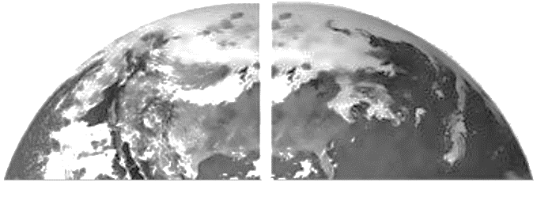

Natural Greenhouse Effect

Human Enhanced Greenhouse Effect

**Air Quality**

Date:

SWBAT: Discuss a variety of air pollutants and how they can be harmful to humans and the environment.

|  |  |  |
| --- | --- | --- |
| Term | Description | |
| Air Pollution | Definition:   * Can be man-made or natural   http://pool.hesperian.org/w/images/thumb/a/a3/EHB_Ch20_Page_454-1a.png/500px-EHB_Ch20_Page_454-1a.png | http://www.atsdr.cdc.gov/general/images/airpollution.png |
| Main Types of Air Pollution | * _________________________________________ – Created by volcanoes and factories. Sulfur can bond with oxygen in air to create acid rain. * _________________________________________ – Created by thunderstorms and combustion engines. Toxic * _________________________________________ – Created by volcanoes and combustion engines.   Can be toxic   * _________________________________________ – airborne solids. Can cause cancer * **_________________________________________ - (CFC’s) a pollutant found in aerosols, breaks down ozone**   **Loss of ozone can lead to harmful UV radiation – HEALTH RISK!** | |
| Sources of  Air Pollution | http://www.cleanairinstitute.org/ial/imagenes/sources.png   * **__________________________________________ – Coal power plants, Industrial Factories** * __________________________________________ – cars, planes, ships * __________________________________________ – aerosols, paint, hair spray * Waste Deposition- landfills create gases as waste breaks down | |
| Solutions to Air Pollution | * ________________________________________- remove gases or particles from a point source location. * Regulation- Country uses standards to prevent too much pollution to come from one location   + Ex. Clean Air Act of 1963 | |
| Air Quality Index | Definition: | |

**Humidity and Dew Point**

Date:

SWBAT: Determine and measure relative humidity and dew point temperature

|  |  |  |  |  |
| --- | --- | --- | --- | --- |
| Term | Description | | | |
| Water in the Atmosphere | Gas 🡪 | Solid 🡪 | | Liquid 🡪 |
| Changing States | * Solid to liquid: ____________________________   + Ice absorbs heat and turns to liquid * Liquid to solid: ____________________________   + Water loses heat, and turns to ice * Gas to liquid:_____________________________   + Heat is released into surroundings | | * Liquid to gas: _____________________________   + Heat is absorbed from surrounding * Solid to gas: ______________________________   + Heat absorbed * Gas to solid: ______________________________   + Heat released | |
| Humidity | Definition:   * **Air that has reached its water vapor capacity is said to be ______________________________________** * Humidity depends on __________________ since different temperatures have different saturation points | | | |
| Relative Humidity  (RH) | * Definition:   + **Indicates _____________________________________ the air is to saturation $$\frac{Actual Moisture}{Maximum Moisture}×100 =Relative Humidity$$** | | | |
| Hot Air vs. Cold Air | * http://geogrify.net/GEO1/Images/Geosystems/EG_7e_Figure_05_04_L.jpgThe warmer the air, the   __________________________________  it can hold   * By changing the temperature of the air you   can increase or decrease the relative humidity  Constant water vapor + higher temp = lower RH  Constant water vapor + lower temp = higher RH  **Warm, saturated air contains ___________________ ____________________________________________**  **than cold saturated air** | | | |
| Specific Humidity | Definition: | | | |
| Hygrometer:  Psychrometer | Measures:   * Made of two thermometers: 1 dry (air temp) and 1 wet (evaporation causes temp to go down) * Compare both thermometers in table to find RH   In a cloud there is no evaporation because air already saturated! So the wet and dry bulb will be the same!   * Hair Hygrometer: Human hair stretches when humidity increases | | | |
| Heat Index | **Definition:**   * High air temp + low RH = air temp feels lower than it really is * High air temp + high RH = air temp feels higher than it really is | | | |
| Dew Point | Definition:   * If the temperature drops to the dew point then the moisture in the air will begin to condense and form dew (> 0 oC) or frost (< 0 oC) | | | |

**Clouds and Precipitation**

Date:

SWBAT: Describe and identify the various cloud types. Describe the various types of precipitation and where they form.

|  |  |  |  |  |  |  |  |  |
| --- | --- | --- | --- | --- | --- | --- | --- | --- |
| Term | Description | | | | | | | |
| Clouds | Definition: | | | | | | | |
| Recipe for Clouds | 1. __________________________________________________: air must be saturated. 2. __________________________________________________: air must be cooled to the dew point 3. **__________________________________________________: provides a surface for condensation to occur Ex: dust, salt, smoke.** | | | | | | | |
| Cloud Formation | As warm air rises and expands, it cools:   * When air reaches a level where its temperature is ___________________________________, condensation occurs to form a cloud. * The level where condensation forms is called the _____________________________________   + The base of the cloud forms here | | | | | | | |
| Orographic Lifting | Definition: | | | | | | | |
| **Frontal Wedging** | **Definition**: | | | | | | | |
| Convergence | Definition**:** | | | | | | | |
| Localized Convection | Definition: | | | | | | | |
| Stability | **Rising moving air = ____________________________**   * Warm air rises into cold air. | | | | **Non- moving air = _____________________________**   * Warm air above cold air * Called: | | | |
| Cloud Types | **Form**   * _____________________________– “hair like”, high altitude, wispy * _____________________________– “pile/pillow”, rounded * _________________________– “ layer”, sheets or layered, no distinction between individual clouds | | | | **Height**   * High: ______us, ______ostratus, ______ocumulus * Middle: __________stratus, __________cumulus * Low: ____________, ____________cumulus, nimbo______________   **Nimbus = “__________________________________”** | | | |
| Vertical Clouds | * _________________________________________________ – puffy cloud usually found at low cloud levels * _________________________________________________ - formed from rising of unstable air   + **Often associated with thunder, lightning, and hail** | | | | | | | |
| Fog | Definition: | | | | | | | |
| Precipitation | Collision-Coalescence | Drizzle: | Rain: | Snow: | | Sleet: | Freezing Rain: | Hail: |
| Cloud Seeding | Definition:   * Achieved by adding condensation nuclei to clouds | | | | | | | |

**Air Pressure and Wind**

Date:

SWBAT: Describe the effect of air pressure on wind & compare air pressure changes with regards to temp, humidity & altitude

|  |  |  |  |  |
| --- | --- | --- | --- | --- |
| Term | Description | | | |
| Air Pressure | Definition: | | | |
| Barometer | Definition:  Mercury or Aneroid Barometer measured in (inches of mercury) or (pounds per inch2) or (millibars) | | | |
| Isobars | Definition:   * The spacing between each isobar indicates pressure change | | | |
| Air Pressure Differences | **_____________________________________________________ creates air pressure differences**   * This difference in air pressure causes a phenomena called wind.   + Wind is when air flows **from** areas of **high** air pressure **to** areas of **low** air pressure | | | |
| **Low Pressure**   * ___________________________________ Rising * **This leads to clouds and precipitation** * Winds rotate in a ___________________ motion * **Low Pressure = __________________________** | | **High Pressure**   * __________________________________ Sinking * **This leads to a clear sky** * Winds blowing away in _______________ motion * High Pressure = ___________________________ | |
| Wind is caused by ____________________________________________________________   * The greater the difference the greater the wind speed. * By looking at your isobars the closer the lines are together, the steeper the pressure gradient   + **Close Isobars= _______________________________________________**   + Widely Spaced Isobars= Low Winds | | | |
| **Coriolis Effect** | **Definition:**  In the Northern Hemisphere to the_______________; In the Southern Hemisphere to the ________________ | | | |
| Global Winds | **Winds caused by ___________________________________ of Earth’s atmosphere.**   * Hot Equatorial air expands, rises and flows toward poles * Cold Polar air is denser so it flows toward the equator | | | |
| Wind Cells | Due to the Earth rotation there are six cells of air on earth   * High pressure around 30oN and 30oS. Low pressure around 60oN, 60oS, and 0o. * High Pressure ___________________________________ * Low Pressure ____________________________________ | | | |
| Trade Winds - blow from | Westerlies – blow from | | Polar Easterlies – blow from |

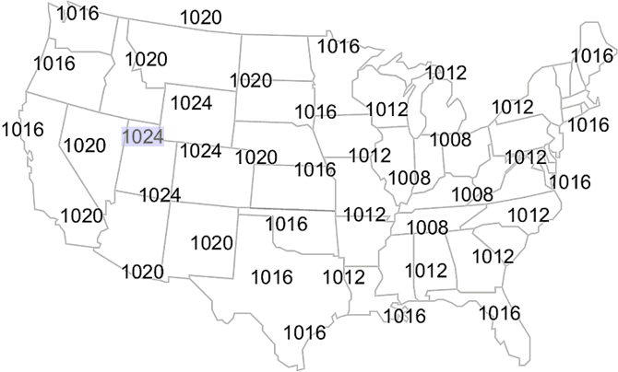

1. Label the center of the high pressure area with a large “H”
2. Label the center of the low pressure area with a large “L”
3. Draw rain drops or snowflakes in the states you would expect to see them in
4. Leave the states you would expect to see clear skies empty
5. Draw arrows around the “H” on your map to indicate the wind direction
6. Draw arrows around the “L” on your map to indicate the wind direction