Water Uses and the Water Cycle
Date:
SWABT: Draw and describe the water cycle. ID and describe sources of freshwater and how to conserve the resource.

All living things need water  Human uses include:  - Hydroelectric Energy |  | Distribution of Water on Earth
Water moves on Earth through the continuous process of the water cycle.
Water Cycle –

The Water Cycle | Description
Evaporation
(liquid gas)
Transpiration
(liquid gas)
Condensation
(gas liquid)
Precipitation | - A decrease in precipitation decreases the amount of infiltration of water into the ground
Infiltration | - Infiltration recharges groundwater supplies
Groundwater | 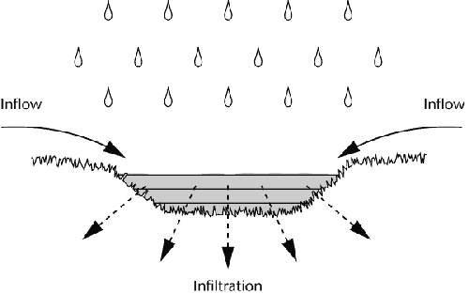  - Vast amounts of water are unseen underground.  - This water can move through the water cycle several ways:  - Transpiration by plants  - Move into surface water like streams  - Move or storage in the ground
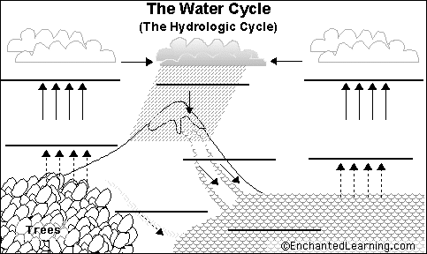

Groundwater, Wells, and Springs
Date:
SWBAT: Draw and describe the layers of groundwater & discuss how water infiltrates the soil. ID sources of groundwater pollution.

Aspects of Groundwater
Term | Description
Groundwater | Water under the lands surface often stored in ______________________________________________________________________________
Aquifer | __________________________________________________________ layers or sediments that transmit groundwater freely.  - Important source of well water
Porosity | Percentage of the total volume of rock or sediment that consists of  ____________________________________________________  - Sorting: Rocks can be sorted into porous or non-porous
Permeability | A materials ability to ___________________________________________________  interconnected pore spaces  - Groundwater moves more slowly when the pore spaces are smaller  - Ex: Fine clay is _________________________________ because its pore spaces are so small water can’t move through them
Zone of Aeration | The region between ___________________________________________  - A _________________________________________ during periods of heavy rainfall or rapid snow melt can lead to flooding  - Since the ground is already saturated (full of water), no more water can infiltrate into the ground which leads to flooding! | 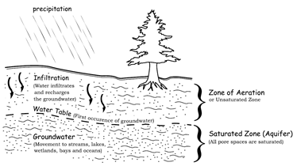
Water Table | the level below which the ground is saturated with water
Zone of Saturation | Area where water ________________________________________________ in sediment and rock  - Groundwater is within this zone
Groundwater and Surface Water Interaction
Term | Description
Ordinary Well | A hole that is dug below the water table and fills with groundwater.  - Pumping is _______________________________  - Several wells drilled in a given area will: _____________________________________________________________________
Artesian Well | Groundwater rises on its own ___________________________________________________________ out of well.  - The pressure is due to the water being sandwiched between two impermeable rock layers  - No pumping is necessary!
Subsidence | _________________________________________________________________ in response to geologic or man-induced causes.  - Caused by pumping water out of the ground.  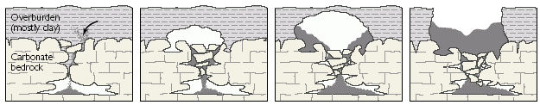
Why is subsidence an issue for North Carolina?
Springs | A section of impermeable rock forces groundwater to _____ and emerge onto the surface of the Earth
Hot Springs | Temperatures increase into the earth.  - Water from hot springs just originate________________________________________________ earth or is heated by magma.
Geyser | Hot springs that ____________________________________________________________________________________________  - Small opening in crust…pressure builds until an eruption occurs  - Ex: Old Faithful in Yellowstone National Park
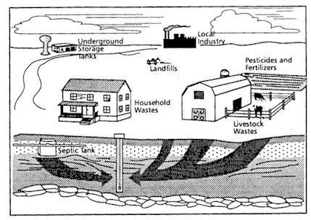
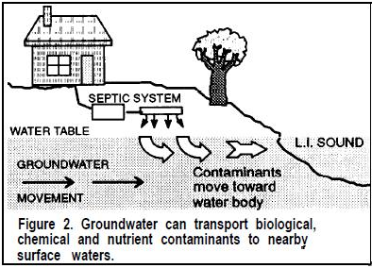
Groundwater Pollution: Ground water is renewable; yet limited
- Ways groundwater can be polluted:
  - ______________________________________________________
  - Pesticides
  - ______________________________________________________
  - ______________________________________________________
  - Arsenic (naturally occurring, factories, mining, and preserving bodies)
Populations Effects on Water Resources
Dates:
SWBAT: Understand where point/non-point source pollution originates.

Water pollution is the addition of ____________________________________________________________________.
- Sources of water pollution in the US include:

  - run-off from fields treated with ____________________________________________________________
  - run-off from areas that have been mined
Types of Water Pollution
Point Source Pollution  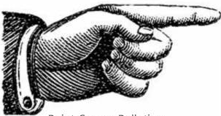  Definition: contamination that enters the environment through a ________________________________ means  Examples:  - Sewage plant pipe  - Coal ash ponds | Non-Point Source Pollution  Definition:  - Results from land runoff, precipitation, atmospheric deposition, drainage or seepage.  Examples:  - _________________________________________  - Arsenic from mining  - Sediment from land runoff
How to Reduce Point and Non Point Pollution
- Use fertilizer and pesticide according to package directions
- Have septic systems ___________________________________
- Conserve sprinkler water
- Never dump anything down a _______________________
- Pick up after your pets. Pet waste left on the ground can spread E. coli, roundworms and Salmonella.
Pollutants move through a water supply __________________________________________
- As water moves towards the ocean, pollutants build up and can become _________________________________
Population Effects on Water Quantity  - Communities across the country are starting to face challenges in maintaining healthy and affordable water supplies  - An increase in population size means there is  Methods of Conservation:  - ________________________________  - Turning off the faucet  - ________________________________  - Water rations  - Watering plants at night or early morning |  | Population Effects on Water Quality  - As populations grow rapidly, health standards find it difficult to keep up.  - This leads to an increase in _____________________ _________________________as pollutants build up.  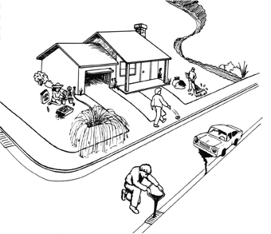
Water Treatment
Wastewater Treatment Systems  - The major aim of wastewater treatment is to remove  before the remaining water is discharged back to the environment.  - Treatment facilities are unable to filter out all contaminants. |  | Drinking Water Treatment System  - Remove small and large sediments from water  - Water forced through filters to remove ___________________________________________  - Removal of __________________________________

River Health
Date:
SWBAT: Identify indicators of freshwater quality.

Indicators of Water Quality
Term | Description: | Changes Caused By:
Turbidity | Definition: The measure of the degree to which water _________________________________________________________ due to the presence of suspended sediment.  - The Mississippi River is an example of a high turbidity body of water | - _______________________________________  - Re-suspended sediments from the bottom  - Waste discharge  - _______________________________________  - Urban runoff
pH | Definition:  - 07 is _________________________________  - 714 is ________________________________  - Surface freshwater is usually 6.5-8  Changing pH in a stream can be an indicator of increasing pollution | - Natural conditions  - Dumping of _____________________________  - _______________________________________  Results of changes in pH:  Most aquatic life cannot withstand water outside of the usual pH range, thus resulting in death
Dissolved Oxygen | Definition:  When D.O. drops too low, fish die. When DO is high, the water tastes better but can damage water pipes. | - Rapidly moving water (_____________________)  - Increased temperature (____________________)  - Discharge from sewer pipes (________________)  - Causes an increase in bacteria
Temperature | Definition:  - Extreme low or high temperatures are only tolerated by hardy fish!  Factory thermal pollution by dumping heated water into lakes and rivers – decreases species in body of water | - ________________________________  - Depth of water  - Shade from shoreline
Nitrates | Definition:  Algae and other plants use nitrates as a source of food. If algae have an unlimited source of nitrates, an algae bloom begins to grow.  - This algae bloom _______________________ dissolved oxygen in water leading to aquatic insects and fish death | Improper use of ______________________________ can lead to algae blooms
Bio-Indicators | Definition: species that are used to monitor the health of an environment or ecosystem. | Example: Amphibians

River Basics and Stream Erosion and Deposition
Date:
SWBAT: Describe the parts of a river and investigate NC’s river basins. ID causes and effects of stream erosion.

Parts of a River
Term | Description
Headwaters | Definition:  - Usually found in the ______________________________________________________________  - Runoff from mountains flow into valleys, valleys become saturated  - Flows to lowest point
Tributaries | Definition:  - More found in mountains than on flat land
Mouth | Definition:
Watershed/  River Basin | 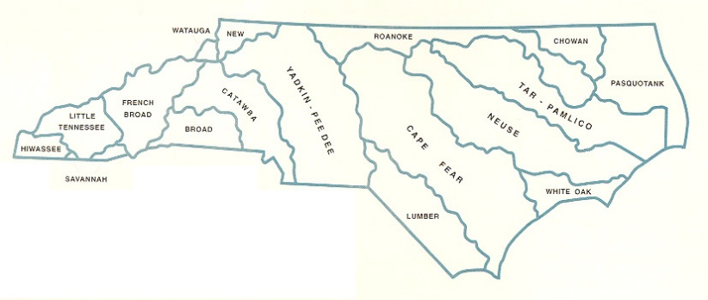  Definition:
Divide | 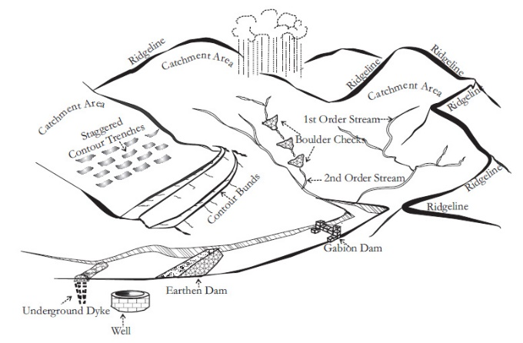  Definition:
Channel | Definition:
Gradient | Definition:  - Usually expressed as the vertical drop of a stream over a certain distance (change in elevation)
Discharge | Definition:  - Usually measured in cubic meters per second
Stream Load | Definition:  - Erosion removes mineral material from the stream banks adding this material to the regular flow of water.  - Higher stream velocity equals higher stream load capacity—streams that move fast erode more and carry more sediment.
Stream Erosion and Deposition
Sediment Deposition
- Sediment is deposited in a stream when there is a _____________________________ in the speed of the water.
- Speed may decrease because of:

  - Bed widening

- Stream deposition can create landforms or change the river valley
Term | Description
Alluvial Fan | Definition:  - Occurs where a stream descending a steep slope reaches flat land.
Levees | - ________________________________________ - raised river banks caused by flooding.  - ________________________________________ - an embankment built to prevent the overflow of a river.
Floodplain | Definition:  - A floodplain forms where a stream cuts mainly side to side  Sediment is deposited making  __________________________________ |  | Flooding Precautions  - _____________________________________  - Flood insurance if you own a home in a high-risk area  - Be prepared to evacuate if need be  - ___________________________________  Why limit floodplain development?  - Allows floodplains to  - Prevents structures from being put in harm’s way
Meander | Definition:  - Erosion occurs on ________________________ of a bend  - Deposition occurs on the __________________________ of a bend.
Oxbow Lake | Definition:
Stages in the Development of a River | Young River  _____________ shaped channel  _____________________ sides | Mature River  _____________ shaped channel  _____________________ sides  Features: |  |  | Old River  _____________ shaped channel  _____________________ sides  Features:
Delta | Definition:  - Occurs because the water slows down as it is emptied into another body of water.
Dam | Definition:
 | Advantages  - _____________________________________  - Hydroelectric power  - Recreational facilities  - Irrigation |  |  | Disadvantages  - Increase accumulation of sediment in water  - _____________________________________  - Destruction of natural habitat for plants and animal

Label the components of a watershed on the diagram using the words listed below
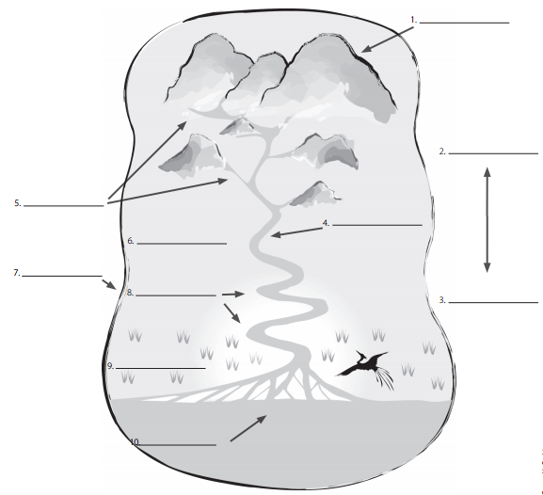
Word Bank
Tributaries
Head of the River
Mouth of the River
Upstream
Wetlands
Watershed Boundary
Main River
Floodplain
Downstream
Meanders

Use the three rivers below to answer the following questions:
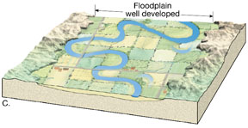
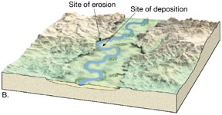
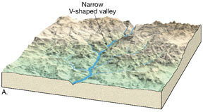

River A River B River C

- ______________________ Highest Gradient
- ______________________ Has the most whitewater rapids and waterfalls
- ______________________ Has the lowest gradient
- ______________________ Youngest (earliest) stage
- ______________________ Widest floodplain
- ______________________ Least likely to flood
- ______________________ Has the most depositional features
Wetlands and Estuaries
Date:
SWBAT: Identify factors of wetland degradation and discuss impacts of saltwater intrusion

Wetlands – Areas of land that are covered by water at least part of the year.
Roles of Wetlands in the Ecosystem
- Wetlands prevent flooding by ___________________________________________________________________
- Natural water quality improvement.

- Fish and wildlife habitat
- Natural products for economy (etc. shellfish, timber, blueberries, medicines)
Wetland Loss  Definition:  - The United States alone has lost more than half of its original wetlands | Wetland Degradation  Definition:  Some human activities that degrade wetlands are:  - Urbanization  - Marinas
Types of Wetlands
_________________________ - An ecosystem in which fresh water from rivers mixes with salt water from the ocean.
- Becomes a nutrient trap: mineral-rich mud drops to the bottom.

____________________________________________ – Freshwater wetland that contains non-woody plants.
- Attract many types of nesting birds.

____________________________________________ – Freshwater wetland that contains woody plants and shrubs.

Water Ecosystems
- Freshwater: lakes, rivers and wetlands (swamps and marshes)
- Mix of fresh and saltwater: estuary
Saltwater Intrusion
Definition:

How does it occur?
- Saltwater has a higher mineral content than freshwater so it is denser and has a higher ______________________
- Saltwater can push inland beneath the freshwater.
Causes
Human activities have increased saltwater intrusion in many coastal areas by:
- An increase in _______________________ of freshwater along a coastal area
- Digging navigation channels
- Digging drainage canals

Saltwater intrusion can be worsened by extreme events like ___________________________ surges and sea level rise
Why is saltwater intrusion an issue for North Carolina?
- It can lead to contamination of ___________________________________________________________________
How to prevent saltwater intrusion?
- The use of injection wells, subsurface barriers, and ________________________________________ would improve water quality and prevent saltwater intrusion.

