Climate
Date:
SWBAT: Define the various climate types of the Koppen Climate Classification System
Term | Description
Climate | Definition:
Main Aspects of Climate | Every climate can be differentiated based upon two factors
Factors that Affect Climate | _______________________________________: (distance from the equator) determines the amount of solar energy received and the prevailing wind belts. |  |  |  | _______________________________________: affects humidity, precipitation, temperature and clouds.
 | ____________________________________: the higher the elevation, the colder the climate. | _______________________________________: topographic features such as mountains play an important role in the temperature and precipitation that falls over an area.
 | _____________________________________________________: large bodies of water such as oceans and seas have an important effect on the humidity and temperature of an area because the temperature of the water body influences the temperature of the air above it. |  |  |  |  | _____________________________: warm or cold currents combined with winds blowing from the ocean to the shore can affect the climate.
 | _______________________________________: can affect both temperatures and humidity patterns in an area because it influences how much energy is absorbed and reflected.
Natural Processes | __________________________________________: the presence of volcanic dust and gases in the air affect the amount of energy that is reflected back into space. It causes the climate to cool. |  |  | ___________________________: changes in ocean circulation can cause the climate to change |  |  | Other: solar activity and earth motions
Coastal vs Inland Climate | - In warm seasons, areas closer to large bodies of water tend to have a moderate climate compared to inland climates.  - _________________________ are slower to heat and hold heat longer than soil and rocks  - In cooler seasons, coastal areas are cooler than inland since water will lose heat ____________________
Koppen Climate Classification system | The five key climate groups based on the annual and monthly averages of temperature and precipitation:
Moist Tropical Climates
- Climates ________________________________________________________.
- Characteristics include:
  - Over 18 degrees C mean temperature
  - Precipitation that can be over 200 cm per year
- There are two types:
 | ____________________ tropical (rainforest in Brazil) |  | ______________________tropical (savanna in Africa)
Dry Climates
- Characteristics: Yearly precipitation is ________________________ as the potential loss of water by evaporation
Moist Mid-Latitude Climates
- Characteristics—based on location and type of winter
  - _________________(-3C to 18C): 30 to 50° latitude mainly on the eastern and western borders of most continents
  - _________________________ (less than -3C): areas affected more by arctic air masses
Polar Climates
- Characteristics: Mean temperature of the warmest month is ____________________________________
Human Impact on Climate
Date:
SWBAT: Describe the factors that affect climate and the conditions they produce

Term | Description
Greenhouse Effect | - The Earth’s average temp is 57º F (14º C)  - Without the natural greenhouse effect the average temp. would be -2º F (-19º C)
Greenhouse Gases | - __________________________________________________(H2O): Water Cycle  - __________________________________________________(CO2): Sources: burning of fossil fuels, solid waste, trees and wood products, etc. Sinks: plants and oceans  - Methane (CH4): fossil fuels, livestock, decay of waste in landfills.  - Nitrous Oxide (N2O): agriculture, industries, fossil fuels, and solid waste.
Climate Change Will Threaten the Health of Many People
Human Activities | - Countries with the largest CO2 emissions  - _____________________________________ - 26%  - _____________________________________ - 17%  - European Union (27 countries) - 13%
Deforestation | - Clearing of forests on a _________________________________________________  - Forests are cleared for lumber, paper products, agriculture and urban sprawl  - Effects on Ecosystem:  - Significant loss of habitat (70% of land animals/plants live in forests!)  - Drives ________________________________________________________  - Forest soils are moist, but without tree cover will dry out  - Help perpetuate water cycle  - Absorbs greenhouse gases (carbon sink)
Sea Level Rise | - 13% of the world’s urban population lives near sea level  - Many cities would be devastated by even relatively small increases in sea level  - _____________________________________________ - As water molecules heat up, they expand and take up more space, causing sea levels to rise  - Rise in _____________________________________________________________________  - Melting of ____________________________________  - Adds tons of fresh water to the oceans  - A recent study says oceans will rise between 2.5 and 6.5 feet by 2100
Can the Oceans Save Us? | The oceans can absorb large amounts of CO2  - Problems:  - The _________________________ water is, the_____________________________ CO2 it can hold  - CO2 levels increase ocean acidity  - Effect on coral reefs – dissolves the calcium carbonate
Solutions | Why is Global Climate Change Hard to Stop?  - Global  - Long term  - ____________________________  - Uneven resources  - Impact to the economy and _______________________________ | What are our options?  - _______________________________________ – the act of decreasing or reducing something  - What can we do?  - Reduce Greenhouse Gases  - Improve Energy Efficiency  - Renewable Energy  - _________________________________  - Know and Reduce Your Carbon Footprint
Biomes
Date:
SWBAT: Identify biomes by their climate and the organisms that inhabit them
Term | Description
Biomes | Definition:
Biomes Determined By | Biomes can be determined by biotic and abiotic factors.
 | Biotic: |  | Abiotic:
Types of Biomes | Tropical Rain Forests  Biotic factors? Abiotic factors?
Temperate Forests
Biotic factors? Abiotic factors?

Taiga (Boreal Forest)
Biotic factors? Abiotic factors?

Savannas
Biotic factors? Abiotic factors?

Temperate Grasslands
Biotic factors? Abiotic factors?

Chaparral (shrub land)
Biotic factors? Abiotic factors?

Desert
Biotic factors? Abiotic factors?

Tundra
Biotic factors? Abiotic factors?

Soils | - Soil type is affected by the _____________________________________________ upon which it sits as well as the amount of physical and chemical weathering that it undergoes.  - Soil changes over time
NC Soil | - North Carolina’s main soil type is ____________________________  - Cecil is found above granitic rock  - Has a thick red subsoil
Biome Adaptation | - Plants and animals have adapted to specific environmental conditions.  - These conditions can be threatened by human activities.
Sustaining Biodiversity
Date:
SWBAT: Discuss the importance of biodiversity and the impact of species extinctions
Term | Description
Biodiversity | Definition:  - A healthy ecosystem includes a wide variety of species.  - There are now an estimated 13 million species of living organisms on Earth.  - There are three levels of biodiversity:
 | 1. |  | 2. |  |  |  | 3.
 | Factors that INCREASE biodiversity  - ________________________________________  - Nutrients, Rain, Temperature  - _________________________________________ |  |  |  | Factors that DECREASE biodiversity  - _________________________________________  - Limitation of nutrients or habitat  - Introduction of invasive species  - Geographic isolation
Endangered Species | Definition:
Threatened Species | Definition:
Extinction | Global Definition: |  |  |  | Species Definition:
One reason to be concerned
- Many species have __________________________________________ to humans as medicines and foods.
  - Quinine (used to treat malaria) comes from the cinchona plant.
  - Digitalis (used to treat heart disease) comes from foxglove.
  - ____________________________________ (Potential anti-cancer drug) from the Pacific yew plant.
HIPPO | HABITAT LOSS
INVASIVE SPECIES
- An organism that is _________________________________________________________on our economy, our environment, or our health.
- Example: Kudzu Vine and Argentina Fire Ants
- _________________________________________ is the best way to reduce threats from invasive species, because once they arrive it is almost ________________________________________ to slow their spread.
POPULATION GROWTH
- Increasing human populations have led to ____________________________________________________
POLLUTION
- The _____________________________________________________________________________ into the environment has a huge impact on species abundance, and can lead to extinctions.
- It’s important to remember that substances that are “natural” can become pollution when they are too abundant in a certain area.
Example: nitrogen and phosphorous leading to algae blooms and dead zones
OVEREXPLOITATION
- Some protected species are killed for their ____________________________________________________
- Killing predators and pests
Efforts to Help | 1. | 2. |  | 3. |  | 4. |  | 5.
Population
Date:
SWBAT: Describe how populations can grow and limiting factors to this growth.
Term | Description
Species | Definition:
Population | Definition:
Habitat | Definition:
Niche | Definition:  - The niche is influenced by biotic factors (food, predators, and mates) and abiotic factors (temperature, sunlight, water).  - The number of different niches is determined by the ____________________________ in an environment.  Predators increase niche diversity by decreasing prey population size.  - A predator that promotes a great niche diversity is called a _______________________________________  - A predator without its own predator is called an ________________________________________________
Community | Definition:
Ecosystem | Includes all the communities in an area, as well as the abiotic factors in the environment.
 | Biotic Factors: |  | Abiotic Factors:
Population Control | Populations have the reproductive ability to produce unrealistically large populations.  Called: |  | Some populations sizes are restricted by a carrying capacity - the maximum population size of the species that the environment can sustain  Called:
Population Limits | __________________________________________________is the maximum capacity of an individual or population to reproduce under optimal environmental conditions.  - Limits to the biotic potential are caused by:  - Disease  - __________________________________________________  - Restricted food resources
Carrying Capacity | Most populations stop growing when they reach their carrying capacity. Limiting factors include:  - Density-dependent factors: predation, parasitism, disease, food competition, living space, water availability  - Density-independent factors: climate, human disturbance, natural disasters
Human Population Limits | 1. | 2. |  | 3.
 | Humans are the only species that have been able to grow so large due to our ability to ____________________
Estimating Population Size | 1. | 2. |  | 3.
Population Pyramid | 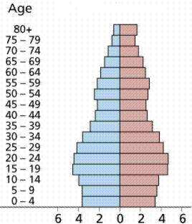  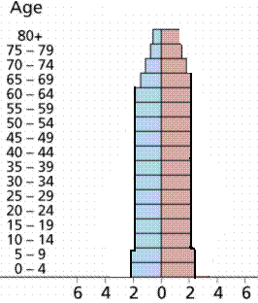  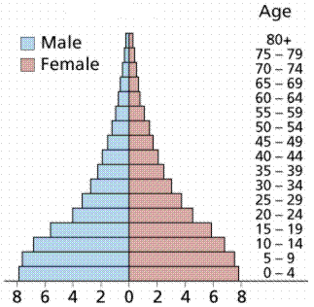  Useful for:
Ecological Footprint
Date:
SWBAT: Identify what makes up an ecological footprint. Analyze specific activities to reduce your ecological footprint

Term | Description
Ecological Footprints | Definition:  - Production and use of goods and services involve land use: have ecological footprints
 | Energy Land: | Consumed Land: | Farm Land: | Forest Land:
 | Transportation Footprint: | Agriculture Footprint:  (Field vs Greenhouse) | Urban Footprint: | National Footprint:
US Footprint | - In U.S. each person uses about 11 acres  - Worldwide average = 3.7 acres/person  - Therefore if everybody were to adopt the U.S. consumptive style, we would need __________________
Inequity | - We all compete for an ecologically overloaded world  - Excess consumption by well off countries takes up ecological footprint that would be used by poorer nations
Resource Distribution | - Wealthiest ___________ of the world uses _______________ of the world’s resources
The Problem | Overconsumption  Solution: |  | Population Explosion  Solution:
Your personal choices impact the availability of natural resources, environmental quality, and global equity!
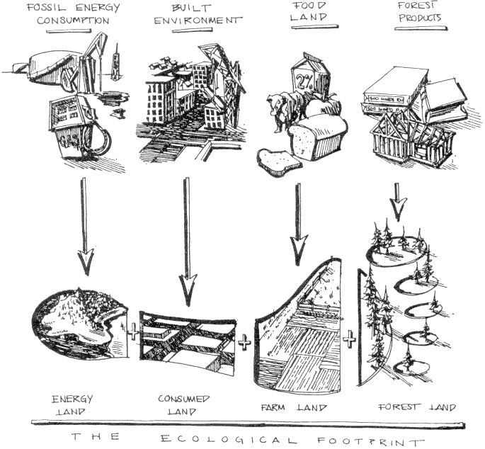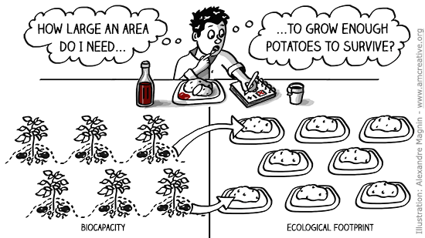
Reduce, Reuse, Recycle
Date:
SWBAT: Identify the differences between reduce, reuse, and recycle

Term | Description
Recycling | 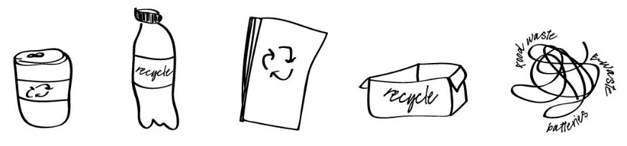  Definition:
Reusing | Definition:
Reducing | Definition:  - Reduced material use in product manufacture  - Decreased toxicity  - Increased useful life through durability and repair-ability  Prevents the generation of waste. ___________________________________________but often-overlooked—strategy.
Trash | - On average…  - 31% _______________________________________________  - 69% _______________________________________________  - 4.5 pounds of trash are produced per person per day
Dump | Definition:
Landfill | Definition:  - Challenges of a Landfill  - __________________________________________________________ from liquids produced in landfill  - Methane production from anaerobic __________________________________________________  - Incomplete decomposition (newspapers in a landfill have been found to be up to 100 years old!)  - As trash decomposes it compacts and settles causing landfills to sink  - Most neighborhoods oppose having a landfill built in their vicinity
