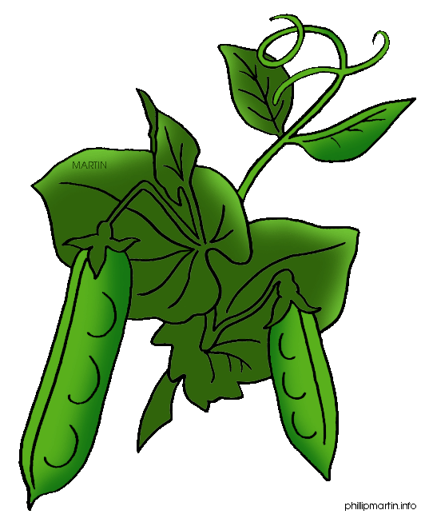
Biology IB Experiment Lab Report & PowerPoint
Purpose: You will design and carry out your own experiment to study the growth of pea plants. You will change ONE variable and test your hypothesis. You will write a formal lab report and create a PowerPoint to show others.
You will:
- Ask a scientific question and create a hypothesis.
- Design and carry out an experiment for at least 1 week
- Gather results and determine if your data supports your hypothesis.
- Write a lab report (typed 12 point font, 1” margins, at least 3 pages)
- Create a PowerPoint and present your experiment (with a partner).
Materials:
- Pea plant seeds
- Sandwich bags
- Styrofoam cups
- Soil (various types—miracle grow, etc.)
- Rulers
- Tin foil
- Water & sunlight sources
- Various sodas, drinks
- Various weak acids and bases (only vinegar, baking soda, soap, or lemon juice)
- You may bring in other supplies, but make sure to get prior approval from your teacher. You may request items from your teacher if you need help with obtaining them.
Experimental Design: Be prepared to work each day on this experiment, until the submission of the final formal lab report.
- Ask a scientific question. What are you interested in studying with your plants? Make sure to record your questions.
- Research plants. How do plants grow? What environmental factors help plants to grow and develop? What is photosynthesis and respiration? What are some characteristics of pea plants? Make sure to record your findings.
- Create a hypothesis (educated guess about what will happen). Make sure to record!
  - USE a “IF…. THEN… statement”.
  - Example: If the plant receives more sunlight, then it will grow taller.
- Design your experiment. What variable did you change in the experiment? What are your controls and constants? What materials will you need? Make sure to record your design!
- Carry out your experiment (FUN PART!) Write down your steps or procedures! (Like the steps in a recipe for cooking) Start sentences with a verb. Good example: Measure 30 mL of water and pour into soil. Bad example: Put soil into pot of plant, leave on counter, and measure plant.
- Gather your results each day. Write down any measurements and observations. (What do you notice about your plants?) Put in data table or chart.
- Conclusion: What can you conclude or determine from your experiment? Does your data support your hypothesis or not?
  - Example: Did your plant grow better with more sunlight than your control (without sunlight)? How can you tell?
  - Explain any human error or what you could have done differently. No scientist is perfect!
You will work in pairs for the experiment. EACH person will write a lab report. Your lab report MUST be worded differently from your partner (if not=cheating=zero). You and your partner will create ONE PowerPoint to show the class your experiment!
PowerPoint:
- You can take pictures and video clips with iPads (show us your plants!)
- Tell us what you learned and what you would do differently now.
- What does your experiment show about pea plant growth?
- Show your data and results.
- No more than 5 slides!
Lab Report (Individual) Graded as Test Grade
- You will have one day in the computer lab to type up final report.
PowerPoint (with Partner) Graded as Quiz
- You will have one day in the computer lab to design your PowerPoint.
Presentation (with Partner) Graded as Quiz

