Name:______________________________________________________________Period:_____________Date:________________________

**DNA -** __________________________________________________ **Function:** DNA is responsible for storing & transferring _____________________________________from one generation to the next. It also contains the codes for making all the ____________________ in your body.

**Building block (Monomer):** ________________________________

**3 parts:** _______________________________ **4 Different Nitrogen Bases:**

______________________________ _____________________ (A) pairs with _____________________ (T)

______________________________ _____________________ (C) pairs with _____________________ (G)

**DNA looks like a twisted ladder. This**

**shape is known as a** ____________________________.

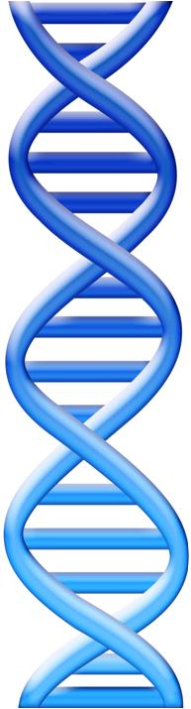

**DNA Replication:**

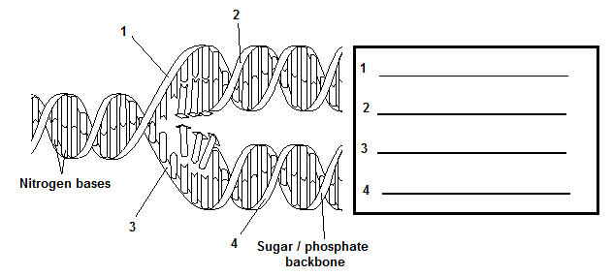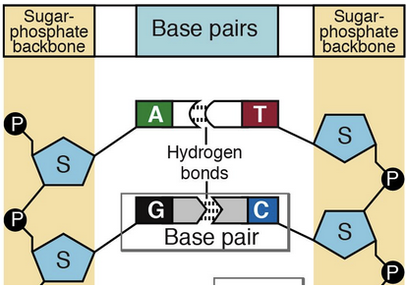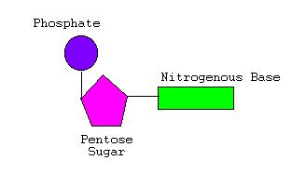****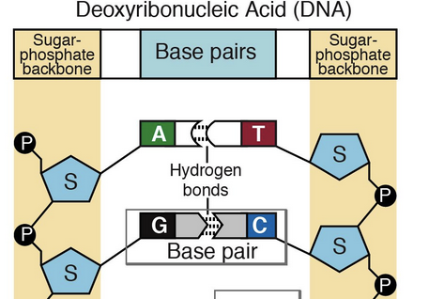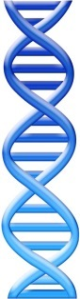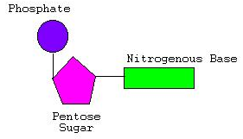

This mode of replication is called ____________________________________ replication because each parental strand is used as a model (or template) for the new daughter (or complementary) strand (Pair Old with New)

DNA replicates before __________________________________________________.

Steps:

1. An ____________________ (called ­­­­­­­­­­­­­­­­­­­­­­­__________________________) comes in and breaks the _______________________ bonds (weak bonds) between the base pairs which causes the strand of DNA to split or “unzips.”
2. The appropriate __________________ are then matched up (by another enzyme called _______________________).
3. What you are left with is ____________________ identical strands of DNA

**Circle one nucleotide.**

**How many nucleotides are in this picture?**

**We say A is _____________________ to T and C is ________________________ to G. this is the ____________________________.**

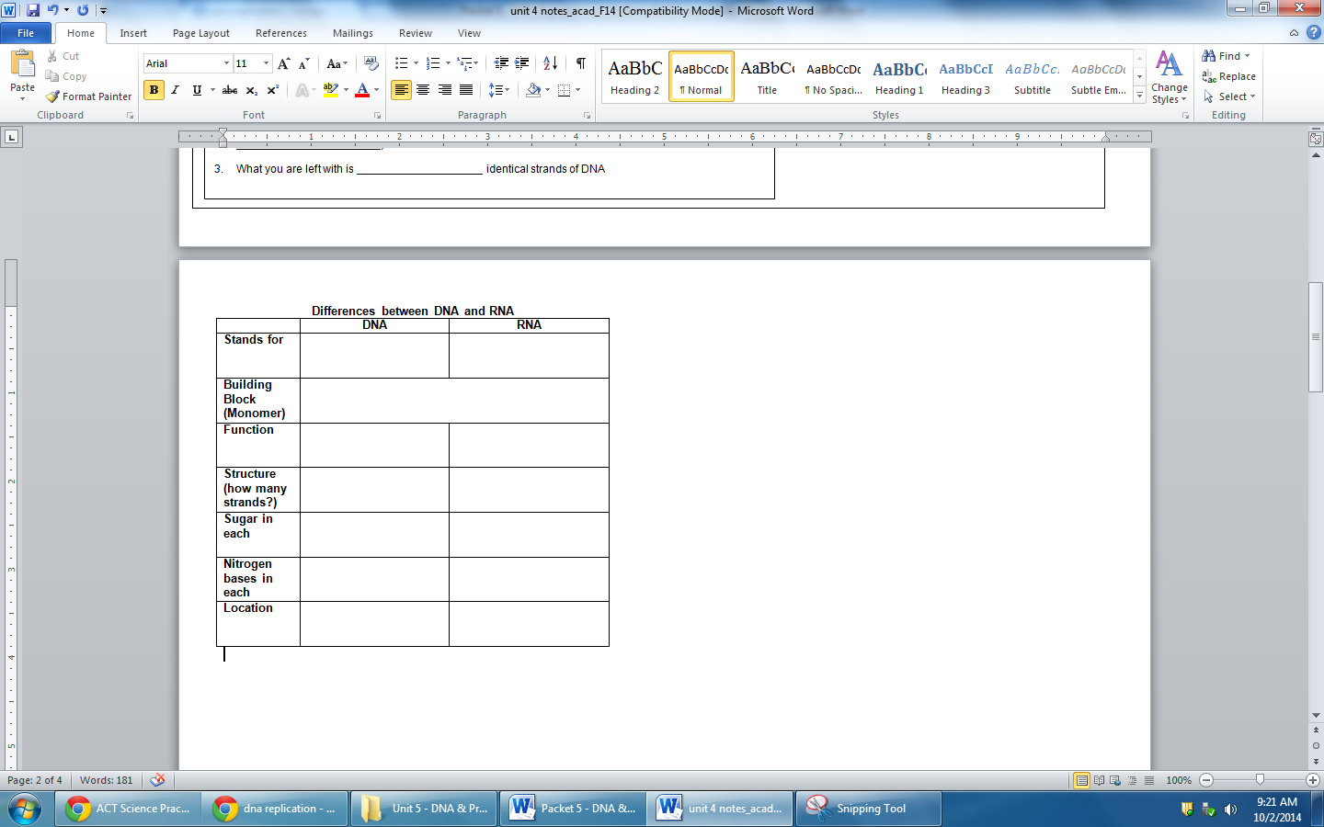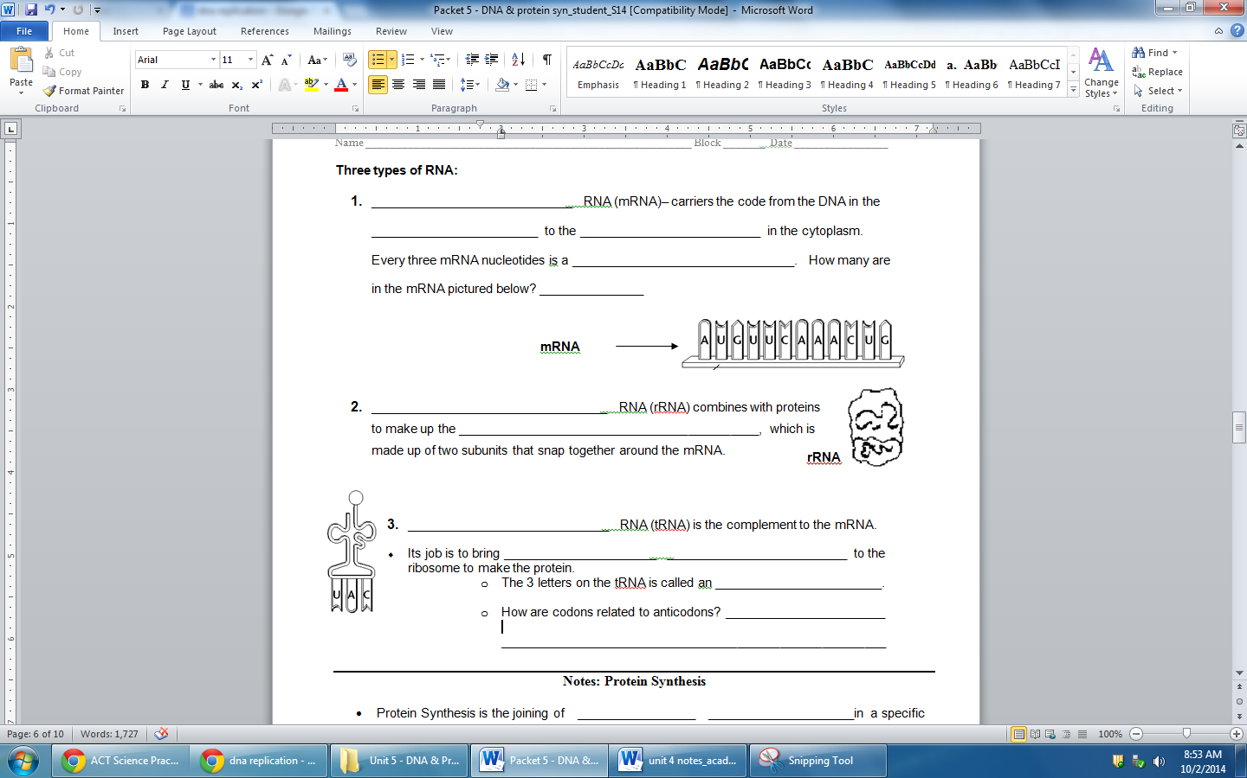

**So DNA contains the codes for making proteins, but why do we even need to make proteins???? Here are several important proteins.**

* ______________________________ - help with the chemical reactions in your body (metabolism).
* ______________________________ - covers the red blood cells and helps carry oxygen to all the cells in your body. Remember your body needs oxygen to undergo ________________________ to produce 38 ____________ molecules giving your body energy.
* _____________________________ - helps maintain blood sugar homeostasis. Excess glucose is stored as glycogen in the muscles and liver.
* _____________________________ - Forms channels in the cell membrane to help transport substances in and out of the cell
* ____________________________ - These help with growth and development
* Makes up your muscles that help your body move.

Is every protein made at all times within an organism? _________________________________________

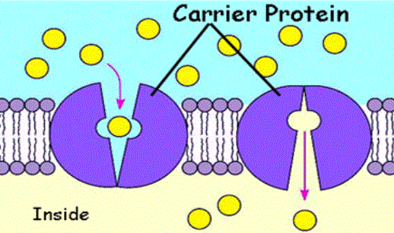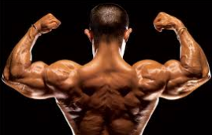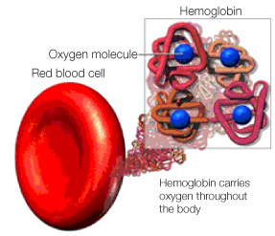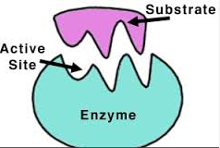

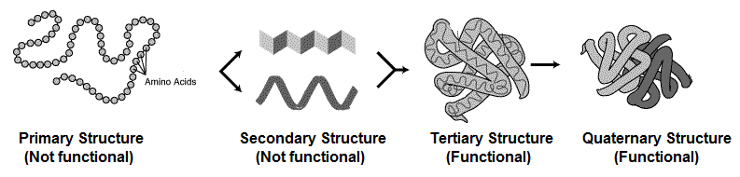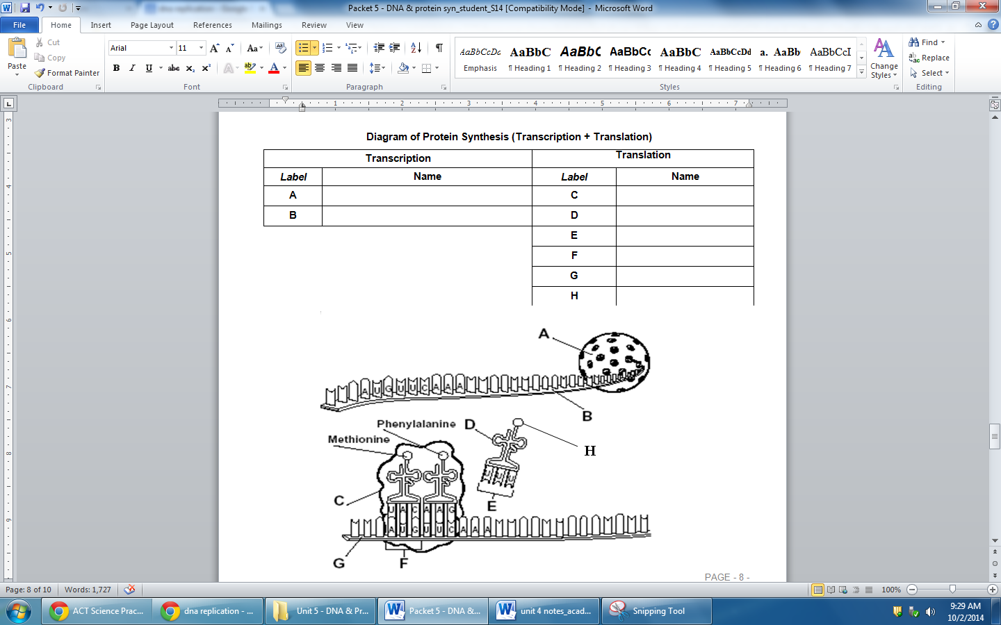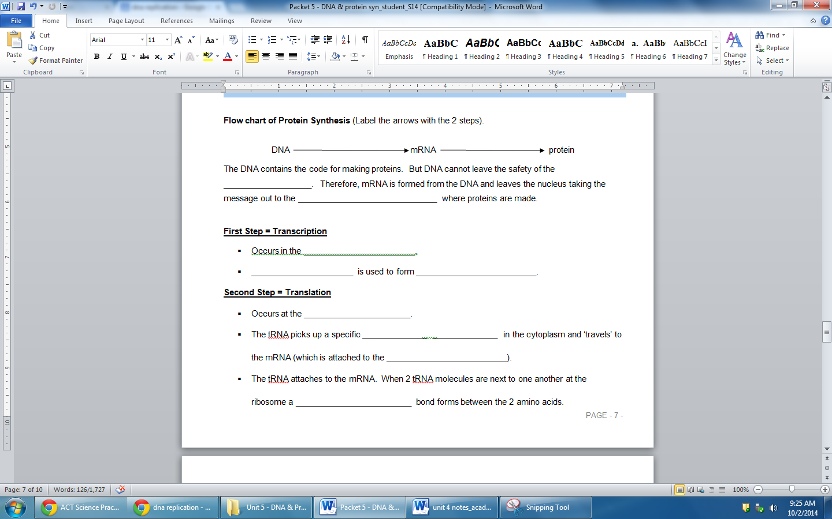

**2 Main types of DNA mutations:**

**If the DNA mutates then the protein may ___________________.**

* _______________ or _______________ - one base is replaced with a different base
* _______________________ - a base is inserted or deleted so the entire sequence is changed from that point on.

**Example:**

Normal Protein: - The red cat ate the fat rat.

__________________ Mutation - The red **h**at ate the fat rat.

_________________ Mutation - The re**b** dca tat eth efa tra t

**Causes of Mutations:**

* Random errors in DNA replication
* mutagens – physical or chemical agents that cause mutations
  + Ex: x-rays, UV rays
* Mutations are not always bad –they are a source of **genetic diversity**

After all the amino acids are put together, the protein is not functional until it ___________________ up into it’s 3-D shape.

**Different structures of a protein:**

