Name:________________________________________________________________________________________________Period:_____________Date:________________________

What is a species?

* + - To be the same species the organisms must:
      * ___________________________________________________________
      * ___________________________________________________________

So

* ________________+ _______________=> **MULE** ………Mule x Mule = no offspring so these are different species
* Lion + Tiger => ___________________­­­­­ => ­­­__________x__________= no offspring so these are different species.

_______________________________ **-** the study of placing organisms in to classification groups (or taxa) based upon characteristics that they possess.

This classification system is constantly changing based on new information:

____________________________ original classification system was made up of 7 levels called **taxa:**

_____________________**-** a new level (which is larger than a kingdom) has been added to the **current classification system.**

There are 3 domains: _____________________, _____________________ & _______________________

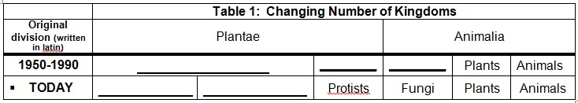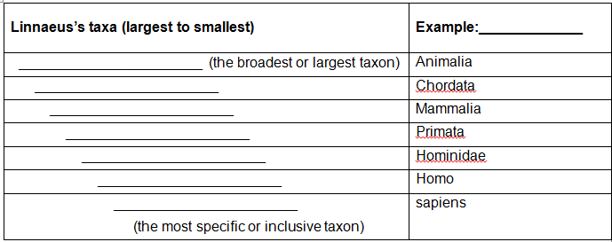

* **Naming Organisms:**
* Linnaeus created a system of naming all living things based on 2 words called: ____________________________________. This is the scientific name and is written in _________________.
* The 2 word name consists of:

________________ _______________

Example: *Homo sapiens*   
 ________ _________.

**Terms from the table (you should know each of these):**

**___________________________________** = no nucleus or membrane bound organelles; simple cells

**___________________________________** = nucleus & membrane bound organelles (cells are more complex).

**___________________________________** = organism made up of 1 cell **___________________________________** = organisms made up of many cells

**___________________________________** = make usable energy/food internally (i.e. photosynthesis)

**___________________________________** = needs to eat to gain energy

|  |  |  |  |  |  |  |
| --- | --- | --- | --- | --- | --- | --- |
| **Classification of Living Things (Kingdom Characteristics)** | | | | | | |
| **Domain** | **Archaea** | **Bacteria** | **Eukarya** | | | |
| **Kingdom** | **Kingdom Archaebacteria** | **Kingdom Eubacteria** | **Kingdom ___________** | **Kingdom ___________** | **Kingdom ___________** | **Kingdom ____________** |
| Examples | Bacteria that live in harsh environments (extremophiles) | Bacteria that live in/on you, strep and E. coli | Paramecium, Amoeba and Euglena | Mushrooms, Mold and yeast (unicellular) | Mosses, Ferns, Pine trees, Flowering Plants | Sponges, Worms, Insects, Reptiles, Fish, **Humans** |
| Cell Type (Prokaryote or Eukaryote) | _______________________ | | _______________________________________________ | | | |
| Number of Cells (unicellular or multicellular) | All _____________________ | | Mostly _____________ | Mostly ____________ | All ____________ | All ___________ |
| Cell Wall (absent or present) | Present | | Present in some | ____________ | ___________ | ____________ |
| Nutrition (Autotroph or Heterotroph) | Both (depends on type) | | Both (depends on type) | All are _____________ | All are ____________ | All are ____________ |
| Important Extra Info. | ALL BACTERIA used to be classified into one Kingdom called Kingdom Monera | | Often categorized as plant-like, animal-like or fungus-like | Called the great decomposers | Carnivorous plants (ex: Venus flytrap) are still considered autotrophs. | Only kingdom in which all organisms lack a cell wall. |
| _____________________________ are not living therefore they aren’t classified in any of the kingdoms. | | | | | | |

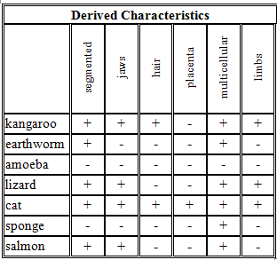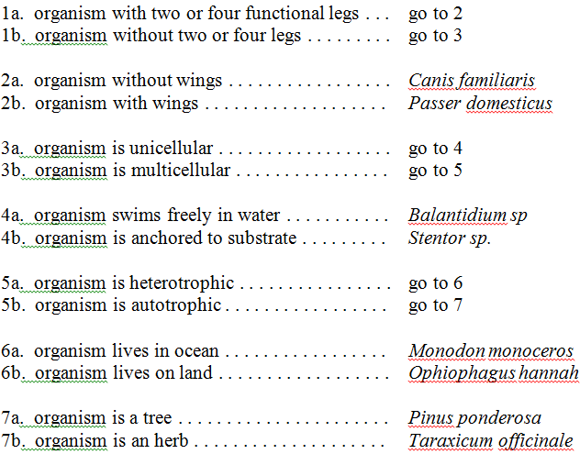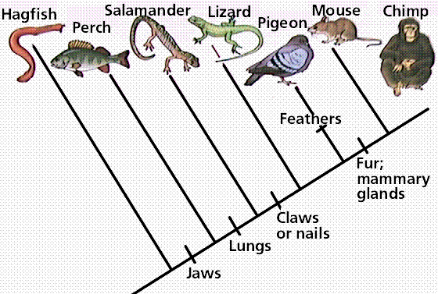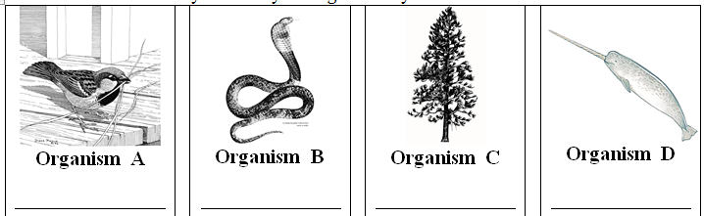

Traits on the axis are called: ________________________.

**Make your own cladogram below based on this data. The organism with the most (-) will be at the bottom and the organism with the most (+) will be near the top.**

**Phylogenetic tree or __________________________** is a diagram that looks a bit like a family tree, showing who the nearest relatives were and who shared a common ancestor, and **when**.

More recent

Old or ____________

1. What features are shared by the salamander & mouse?

__________________________________

1. Does the hagfish possess a jaw? _______

A classification key, also knows as a __________________________ key, is useful in identifying unknown organisms (but is not limited to being used with living things).

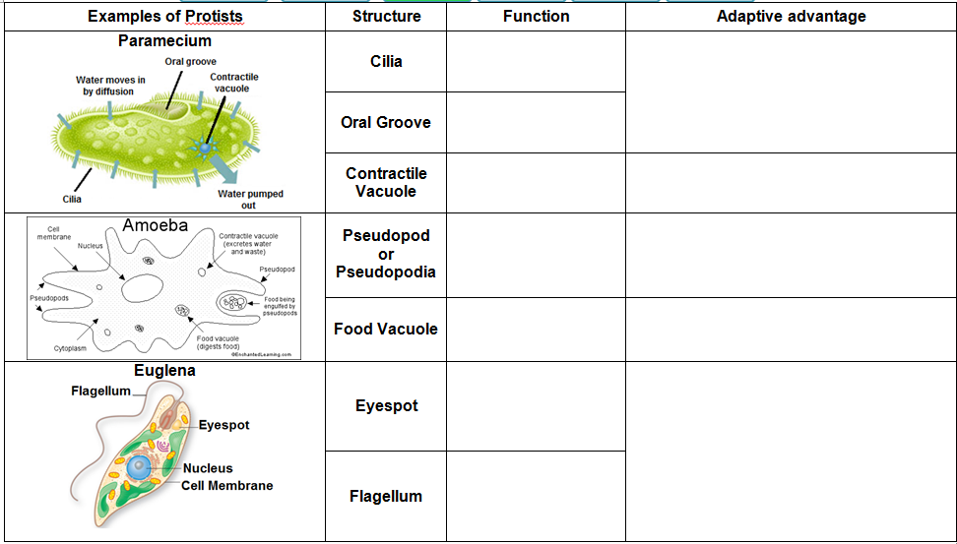

* **These single-celled eukaryotic protists gave rise to the 3 other eukaryotic kingdoms:**
* **__________________________**
* **__________________________**
* **__________________________**

**Based on the cladogram:**

* What is the ancestor of plants? _________________
* What did plants evolve in order to survive on land and avoid drying out? _________________

**Evolution of Plants**

**Kingdome Plantae:**

* _____________________ (made up of many cells)
* All _______________________ cells with a nucleus
* Their cells are surrounded by a ___________ _____________made of ___________________.
* Are ____________________________ that undergo photosynthesis (they make their own food);
* Their green color comes from a pigment called __________________________________.

[Type a quote from the document or the summary of an interesting point. You can position the text box anywhere in the document. Use the Drawing Tools tab to change the formatting of the pull quote text box.]

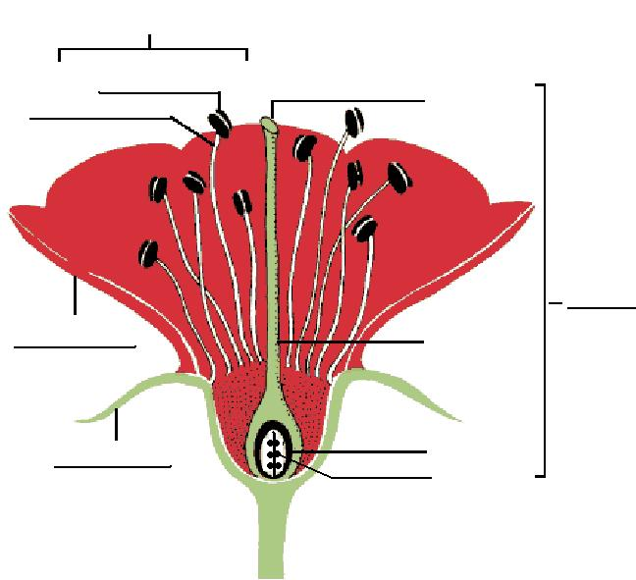

**Sexual Reproduction in Flowering Plants (Angiosperms):**

**How do plants get what they need for photosynthesis?**

* **Water** is absorbed by the __________________ and travels through the _________________________________ of the stem into the leaves. There are 2 types of vascular tissue: ___________________ - transports water up

___________________ - transports nutrients (glucose) from the   
 leaves throughout the plant.

Excess water is released through the ________________, an opening on the leaves. In periods of drought, plants keep their stoma __________________ especially during the day.

* **__________________________** gas enters through the stoma and is used to make glucose
* **____________________________** in the chloroplasts of the leaves absorbs sunlight
* **What happens to the products of photosynthesis?**
  + The oxygen ______________________ through the stoma.
  + The __________________ stays in the plant and is used for energy and to make structures inside the plant.
* __________________________ - organisms that are not closely related evolve similar traits due to living in similar environments. These are ________________________ structures.

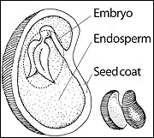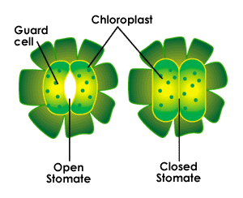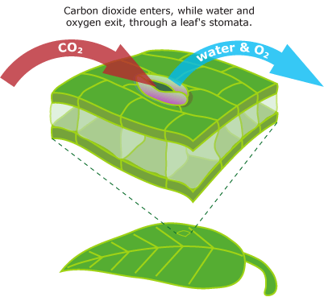

**After Pollination** occurs, a fertilized egg forms into an embryo inside of a _________________ with 3 basic parts:

1. _______________________ - another term for the baby (plant)
2. _______________________ - surrounds & protects the baby plant
3. _______________________ - the food that the embryo will consume to survive until it is able to grow leaves and undergo photosynthesis.

Plants spread their seeds by water (coconuts float), wind (dandelions) and animals (burdocks). Why is it good for the seeds to spread away from the parent plant?____________________________________________________

Seeds remain dormant until _______________ & _______________ are just right.

Plants also respond to the environment. This is called a ________________. Example: A stem bending towards the light is ________________________.

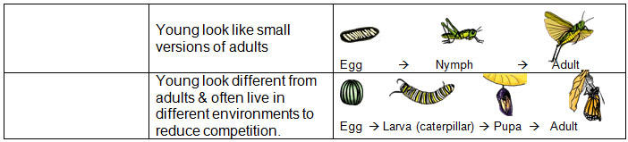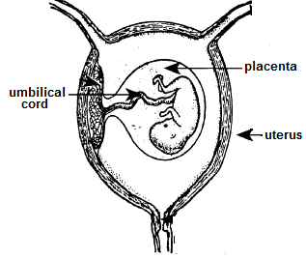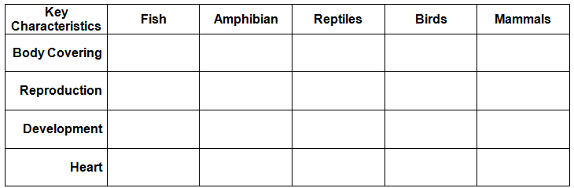

**Growth & Development**

* Some animals like arthropods (crabs, spiders, insects) must ___________________ or shed their exoskeleton in order to grow.
* Animals use chemicals called ___________________ to help cause changes needed for growth & development.
* Some organisms, including grasshoppers & frogs, undergo ____________________________ or a major change to become an adult. **There are two types:**

Why might it be an advantage for the juvenile (tadpole) and adult frog to live in different environments?

**Reproduction**

Most animals reproduce ___________________ which creates genetic variation Fertilization and development can be ___________________ or _____________________. Animals that rely upon external fertilization and/or development typically lay 100’s to 1000’s of eggs. Why? _____________________________________________________

Most mammals have **internal** development – baby develops inside mom surrounded by a ______________________ which controls nutrient and gas exchange between mom and baby.

**Life Functions of Animals:**

**Kingdome Animalia**

There are 9 animal phyla. One phyla contains mostly vertebrates (animals with a ___________________). In this phylum there are 5 classes. These are in the table below.

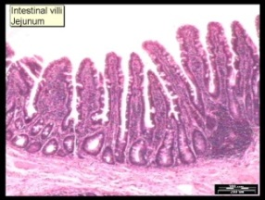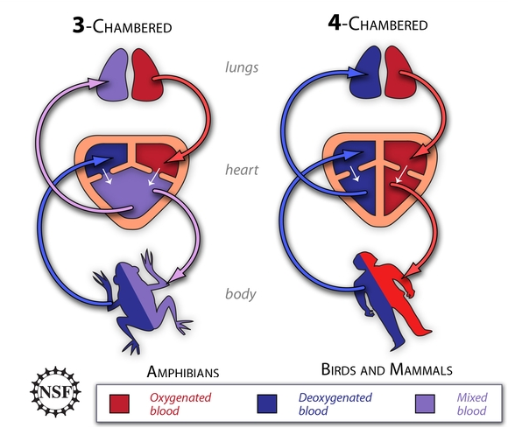[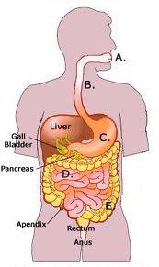](http://www.google.com/imgres?um=1&hl=en&tbo=d&biw=1440&bih=732&tbm=isch&tbnid=-n39jJ78PYmlhM:&imgrefurl=http://avialoi.com/modules/com_joomfish/?digestive-system-of-humans-1778&docid=of8xXbqxqDGDIM&imgurl=http://www.glogster.com/media/1/4/4/96/4049619.jpg&w=271&h=456&ei=kqvCUPi4E4L88gSalIGgCQ&zoom=1&iact=hc&vpx=696&vpy=324&dur=949&hovh=291&hovw=173&tx=120&ty=200&sig=112403574204921376778&page=1&tbnh=145&tbnw=81&start=0&ndsp=37&ved=1t:429,r:23,s:0,i:158)

**Nutrition**

Animals are _______________________________, which means they must eat.

The typical digestive system of animals includes a mouth, esophagus, stomach, small intestine and large intestine.

* C. The _____________________________ breaks down the food.
* D. The ____________________________ main job is to absorb the nutrients from the food. There are many blood vessels attached to the small intestine so the nutrients enter directly into the blood stream and are transported throughout the body.
* E. The ___________________ absorbs excess water and creates solid waste. This system is modified depending on an animal’s diet.

The intestine is the longest part of the digestive system. It is not a smooth tube, but instead the inside surface is covered with many folds (villi).

**How does the surface of the small intestine help with its function?** __________________________________________________________

**Transport**

Most animals have a ______________________ system to transport food, gasses and wastes throughout the body.

The circulatory system of many animals includes a ________________ to pump the blood through the arteries, veins and capillaries.

In larger organisms this network of blood vessels is necessary to ensure blood carrying nutrients and oxygen makes it to all parts of the body.

* Amphibians and some reptiles have a ____ chambered heart and are __________________ - rely on the environment to maintain their body temperature.
* Birds and mammals have a ___ chambered heart and are _______________________, maintain own body temperature internally.
* A 3-chambered heart would not work for humans because there is mixing of oxygenated and deoxygenated blood so both are sent out to the body. This system works in amphibians because they have another method of getting oxygen into their blood stream… using their ______________.

**Respiration**

Animals take in __________________________ and release _______________________.

Amphibians, reptiles, birds and mammals all have __________________. There are many blood vessels within the lungs so the oxygen can go right into the bloodstream for delivery throughout the body.

* Some organisms such as frogs and worms can also breathe absorb oxygen through their ________________. The skin of these organisms must stay _______________.
  + What do tadpoles use for gas exchange? ________