Land Use
Date: _________________
SWBAT: Differentiate between renewable and nonrenewable resources. Discuss the positive and negative consequences of different land uses.

Natural Resource: __________________________________________________________________________________
__________________________________________________________________________________________________
 | Renewable Resource | Nonrenewable Resource
Definition
Examples

NC Forestry Resources (List 2): ______________________________________________________________________________

NC Agriculture Resources (List 3): ____________________________________________________________________________

Positive Consequence (2) | What is Industrialization? | Negative Consequences (3)
Introduction of: Large-scale new manufacturing, advanced technology and other money making activities into an area, society, country, etc.
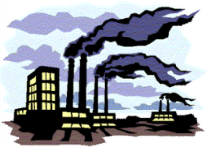
Positive Consequence (2) | What is Urbanization? | Negative Consequences (4)
New towns and cities are formed:
- Population becomes larger
- More people live and work in central area

Heat Islands: A city that has ____________________________ due to having asphalt, buildings, and other dark structures that absorb and hold heat longer than natural environments
Heat Island
Consequences of Heat Islands | Heat Island Mitigation
Negative  - _______________________: 1-10 degree Fahrenheit  - Increased Energy Demand | In order to combat heat island:

Positive Consequences (2) | What is Deforestation? | Negative Consequences (3)
Natural forests are cleared through logging and/or burning
Since 1970, 20% of the Amazon Rainforest has been cut down.

Obtaining Energy Resources: Mining and Reclamation
Date: ______________
SWBAT: Discuss mining methods and restoration.

NC Mining Resources (List 3): _______________________________________________________________________________

Underground Mining | Surface Mining Methods
- Drift Mine  - Slope Mine  - Shaft Mine | 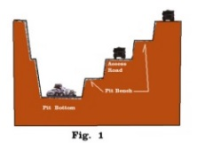  ________________________: Machines are used to dig large holes in the ground and remove the ore. | 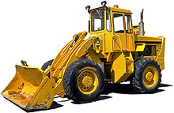  ____________________________: Huge bulldozers and other machines are used to clear away large strips of the Earth’s surface.

Effects of Mining | How to reduce destructive effects…
- Disruption of the land’s surface.  - Waste materials left behind.  - _______________________________  - _______________________________  - _______________________________  - Uses large amounts of energy. | - Reclamation: ____________________________________________ ________________________________________________________  - Re-using or recycling.  - ________________________________________________________  - Stiff fines or fees.

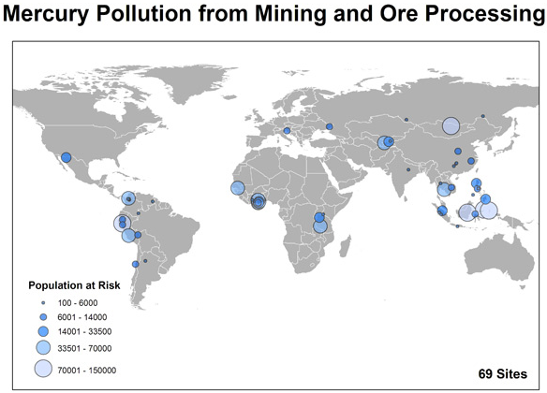

Obtaining Energy Resources: Fossil Fuels
Date: ________________
SWBAT: Describe fossil fuels, how they formed, and identify ways to conserve limited supplies.

Fossil Fuels
- Main energy sources that are formed from the remains of plants and animals.
- Energy released when burn runs cars, machinery and generators.

Fossil fuels are also the major source of air pollution and therefore, the major contributor to global warming!

Increasing Energy
1. _________________________
Definition: A soft organic material consisting of partly decayed plant matter with deposited minerals
Extraction Methods:
____________________________

2. _________________________
3. _________________________
4. _________________________
Definition:
Petroleum
Hydraulic Fracturing (Fracking):
Technique for ____________________ natural gas from “tight” rock (_______) structures _______________________ ________________________________
Definition:
Natural Gas
- Contains carbon and hydrogen
- Refined as gasoline, kerosene, lubricants, etc.
- Used to heat homes, run cars, in plastics, fertilizers, dyes, medicines…
- Must drill wells to tap source
- Often found with natural gas

Coal
____________________________________
- varies in the amount of carbon (more carbon = more energy)
- ____________________________________
- at the present rate of use it could last hundreds of years…maybe

Fossil Fuels
Alternative Energy
Date: ____________
SWBAT: Identify and describe types of alternative energy.

Solar Energy:

Advantages | Disadvantages | Practical for NC?
Solar Energy Collection:
- Active Solar – Collect solar heat
- _______________________________ - Southern facing windows
- Photovoltaic Cells – Convert light into electricity
- _______________________________ - Focus light onto water tanks to create steam

Nuclear Energy:

Advantages | Disadvantages | Practical for NC?

Wind Energy:

Advantages | Disadvantages | Practical for NC?

Hydroelectric Energy:

Advantages | Disadvantages | Practical for NC?

Geothermal Energy:

Advantages | Disadvantages | Practical for NC?

Tidal Energy:

Advantages | Disadvantages | Practical for NC?

Biomass Energy:

Advantages | Disadvantages | Practical for NC?

